**FULL STACK ROBUST CI/CD PIPELINE**

**Overview**

This document provides step-by-step instructions for setting up a CI/CD pipeline using AWS, Jenkins, SonarQube, Docker, and GitHub. The project involves deploying a sample Petclinic application.

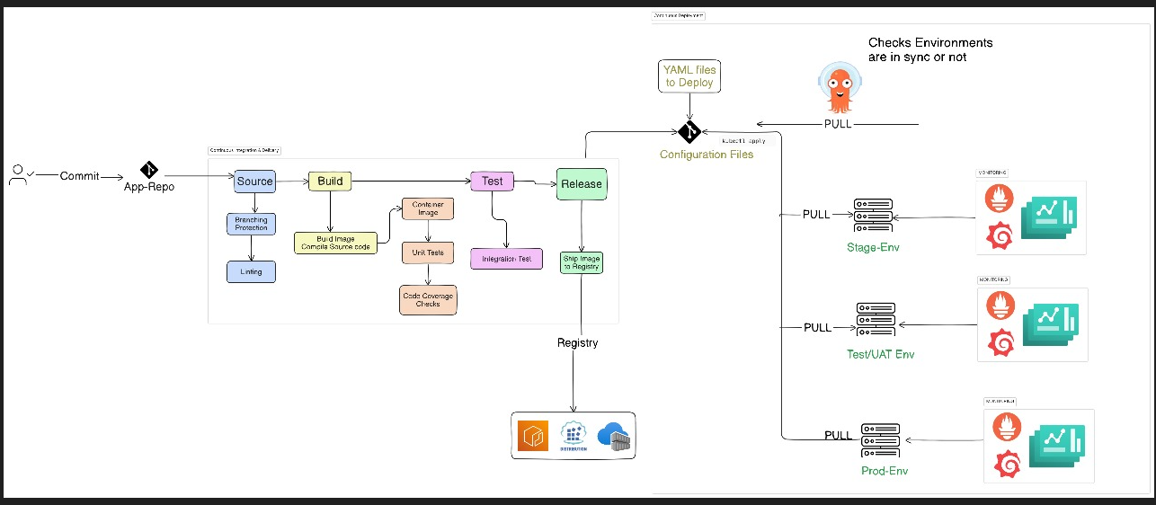

**Prerequisites**

* AWS account
* GitHub account
* Putty installed on your local machine
* Ubuntu AMIs for AWS instances
* Basic knowledge of Jenkins, Docker, and SonarQube

Petclinic project

1. First we have to create vpc

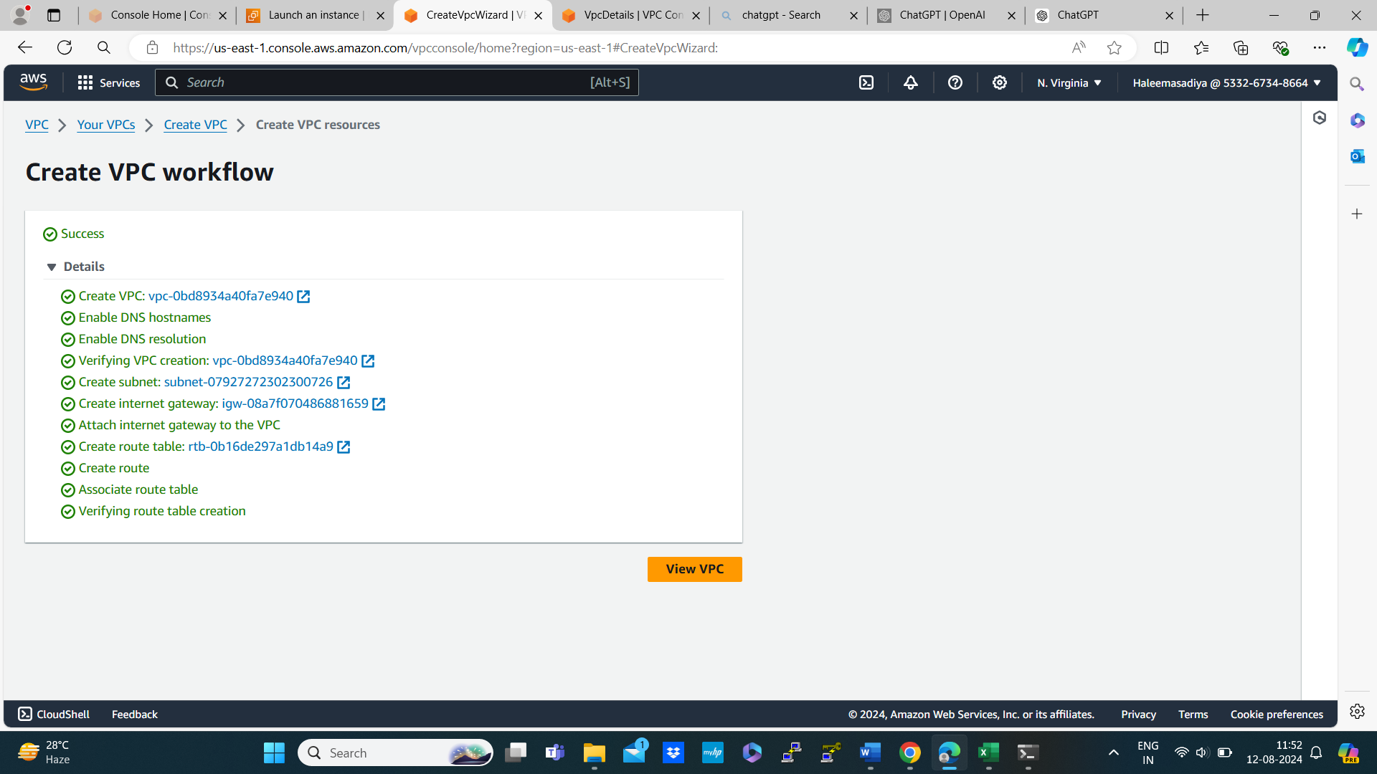

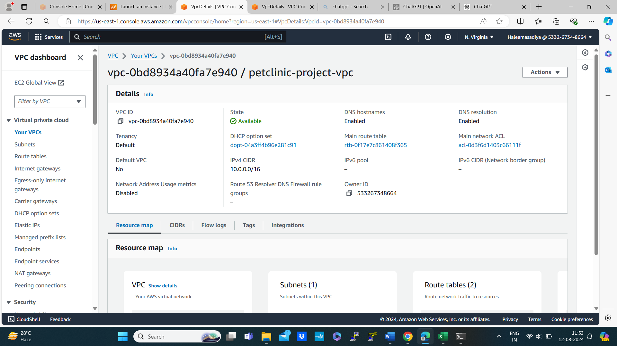

1. With this vpc we have have to launch aws instance ubuntu with t2.medium

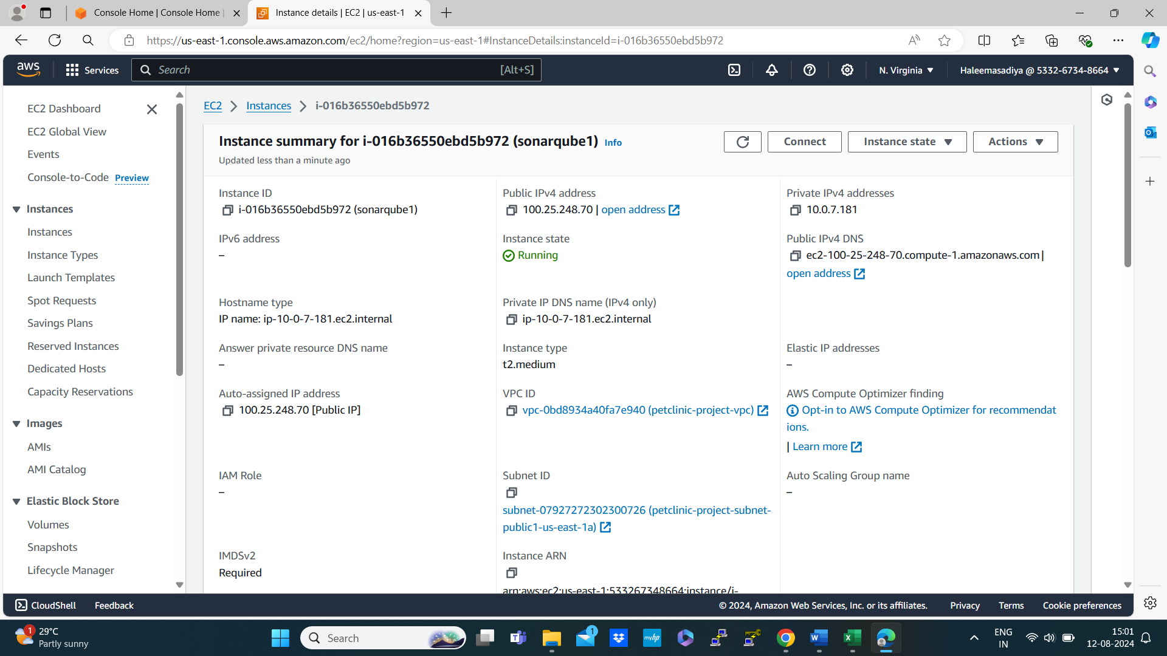

Instance launched successfully the edit security groups allow ssh http and sonarqube

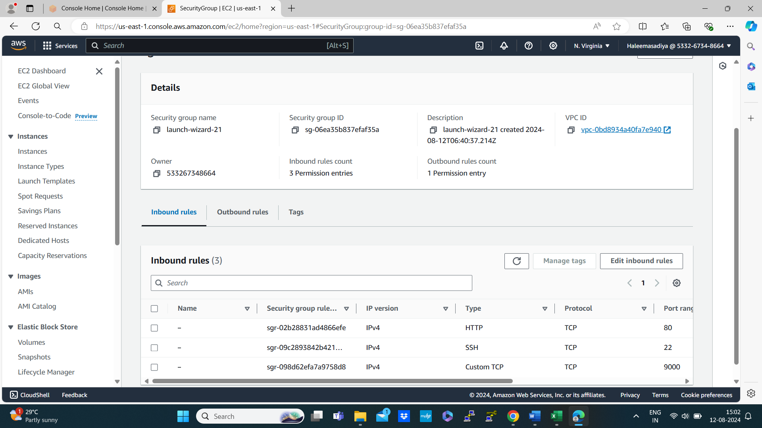

Connect it using putty

Make sure putty is installed in your pc

* Then copy the public ip or DNS of your instance
* Open putty

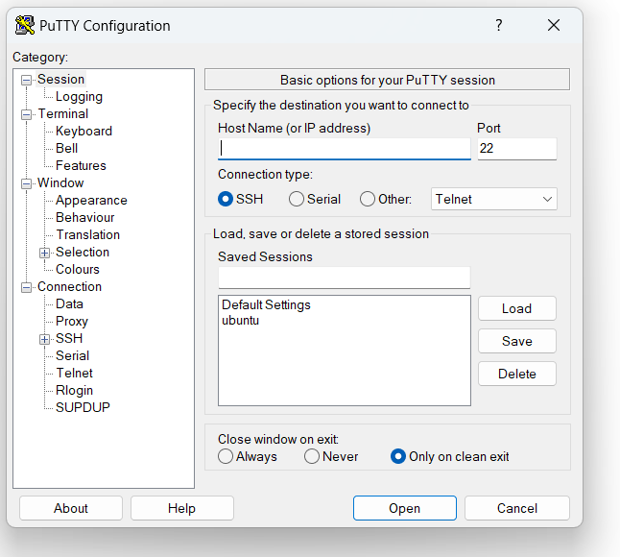

* Click on ubuntu then load now copy public ip/dns of instance (which we want to connect) under Host Name
* Then go to ssh present in bottom left click on it then credential
* Then browse for keypair which we create at the time of instance creation then connect the instance
* Ubuntu terminal will open the enter the password in my case the password is 123

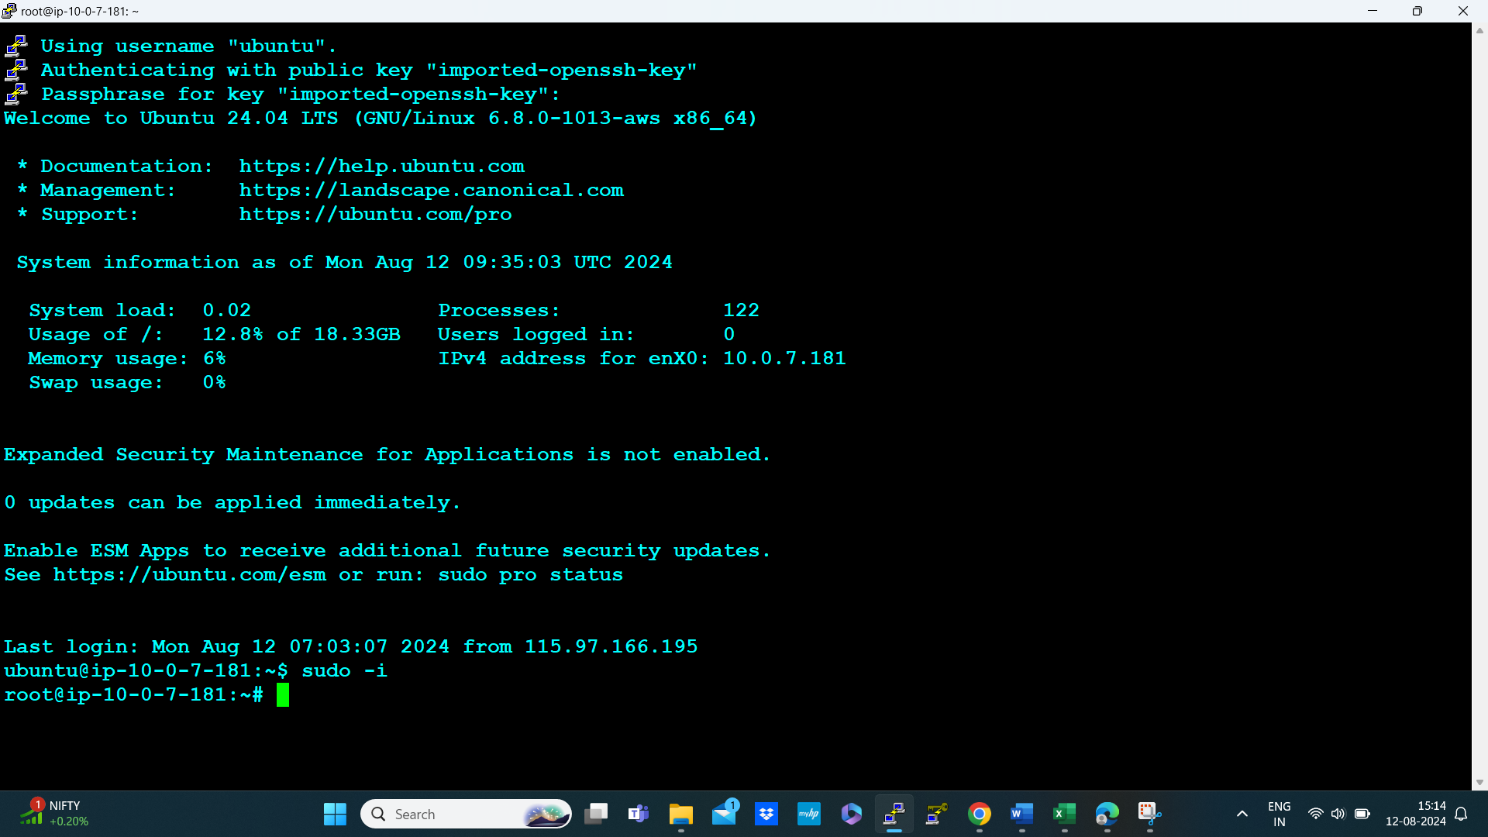

Then install docker in the server

Steps to install docker

**Step 1: Update Your System**

Start by updating your package index and ensuring that you have the latest updates:

# sudo apt update

# sudo apt upgrade -y

**Step 2: Install Prerequisites**

Install the packages required to allow apt to use a repository over HTTPS:

# sudo apt install apt-transport-https ca-certificates curl software-properties-common

**Step 3: Add Docker's Official GPG Key**

Add Docker's GPG key to your system to verify the integrity of the Docker packages:

# curl -fsSL https://download.docker.com/linux/ubuntu/gpg | sudo apt-key add –

**Step 4: Add Docker's Repository**

Add the Docker APT repository to your system:

#sudo add-apt-repository "deb [arch=amd64] https://download.docker.com/linux/ubuntu $(lsb_release -cs) stable"

**Step 5: Update Package Index Again**

After adding the Docker repository, update the package index again:

#sudo apt update

**Step 6: Install Docker Engine**

Install Docker:

#sudo apt install docker-ce

**Step 7: Verify Docker Installation**

To verify that Docker is installed correctly, check the Docker version:

#docker –version



* Create a docker container for pulling sonarqube image and create the container with that image
* Go to docker hub official website [www.dockerhub.com](http://www.dockerhub.com)
* Search for sonarQube image

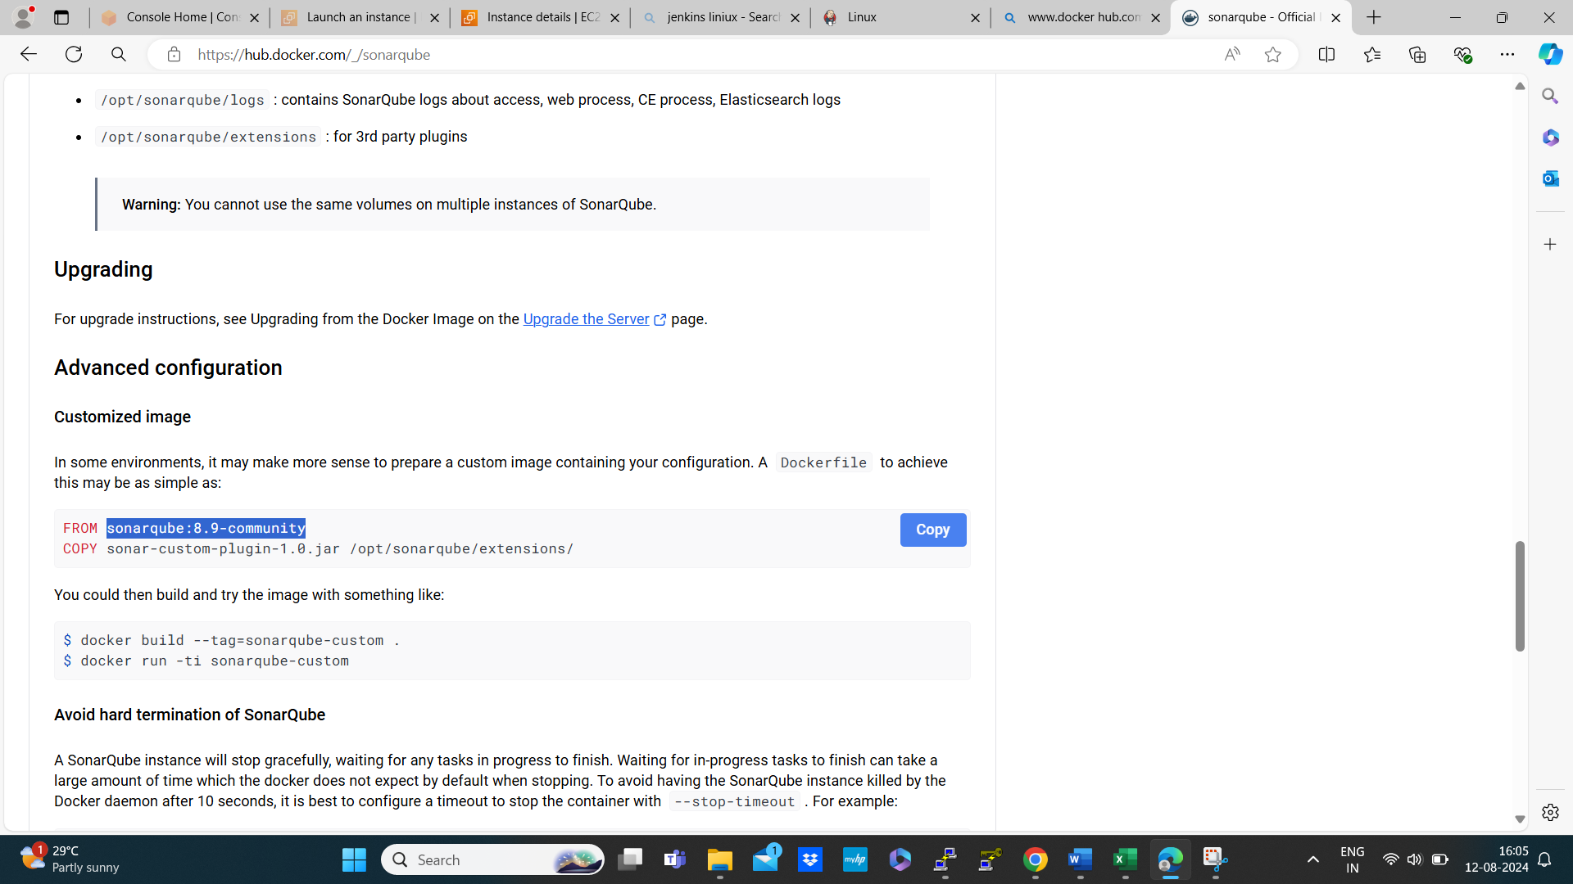

* Copy the sonarqube:8.9-community past it in the commans

# docker run --name sonarQube -d -p 9000:9000 sonarqube:8.9-community

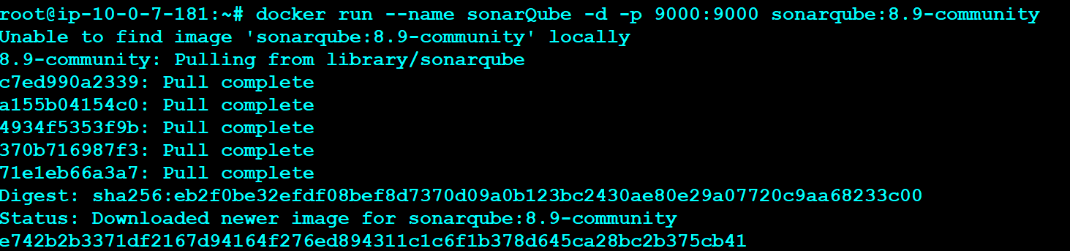

* By running the command docker ps observed that the container is running on the port no 9000



* Then allow 8080 port number in Jenkins-server

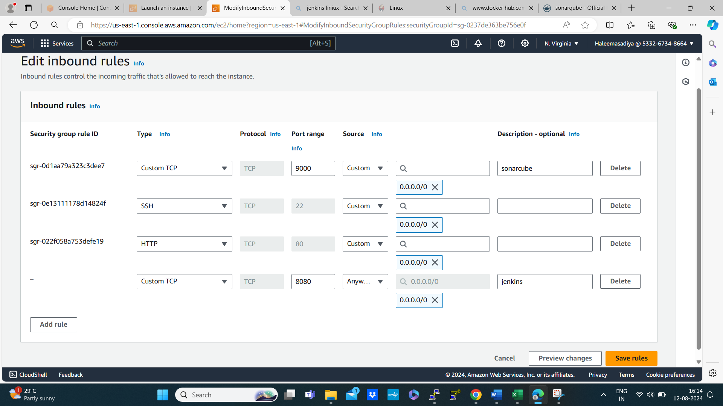

* Make sure all these port number must be allow traffic in Jenkins-server
* Then connect to sonarqube server



* Copy the ipaddress and past it in the browser with port number 9000

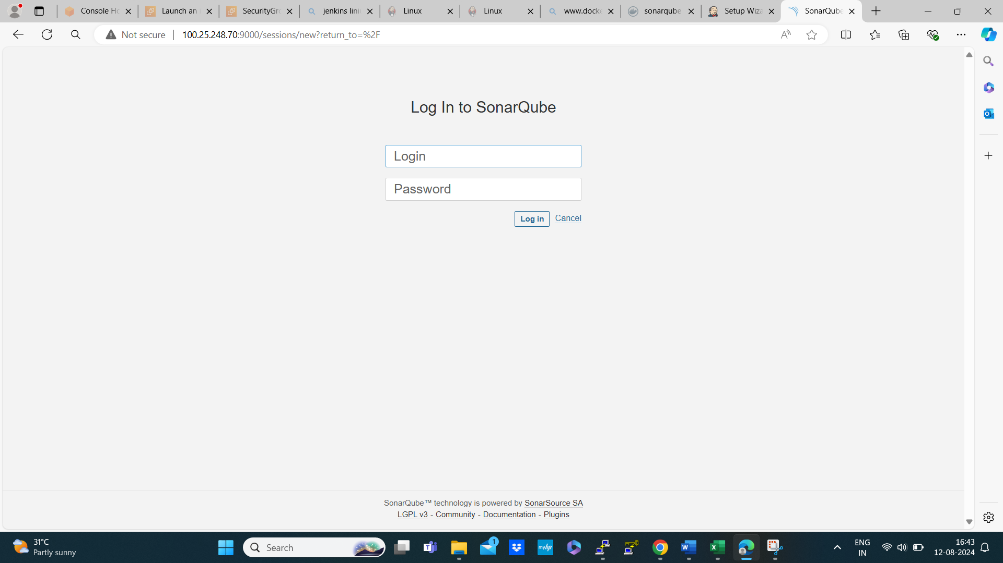

* The default id and password is admin

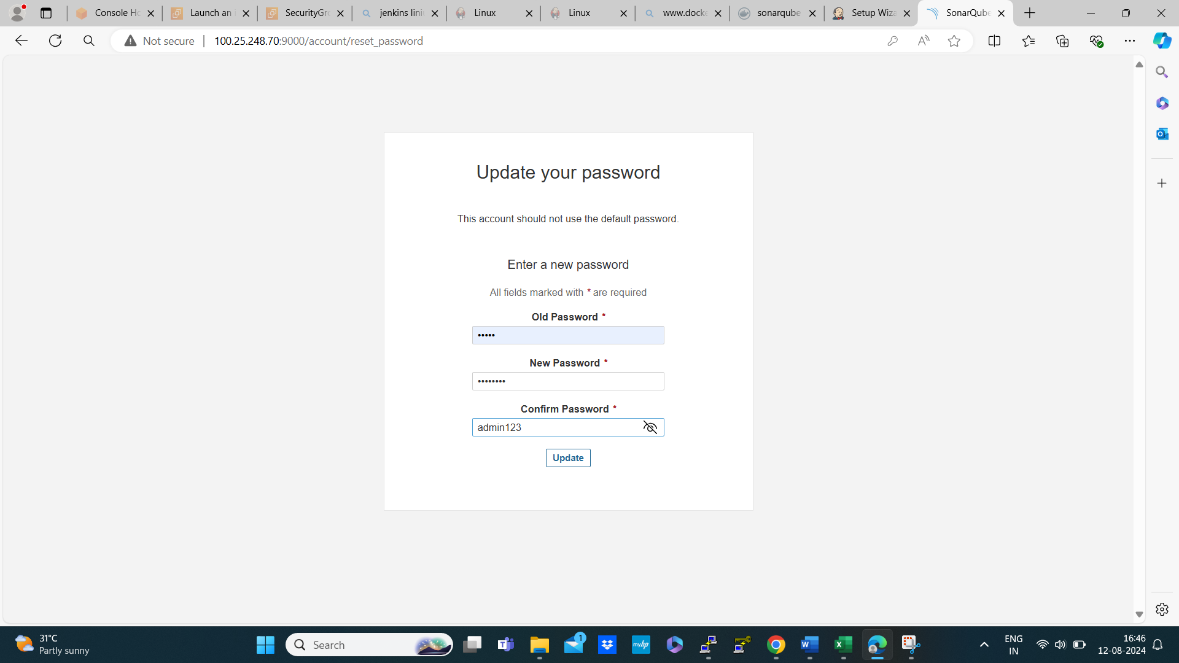

* We are updated a password as admin123

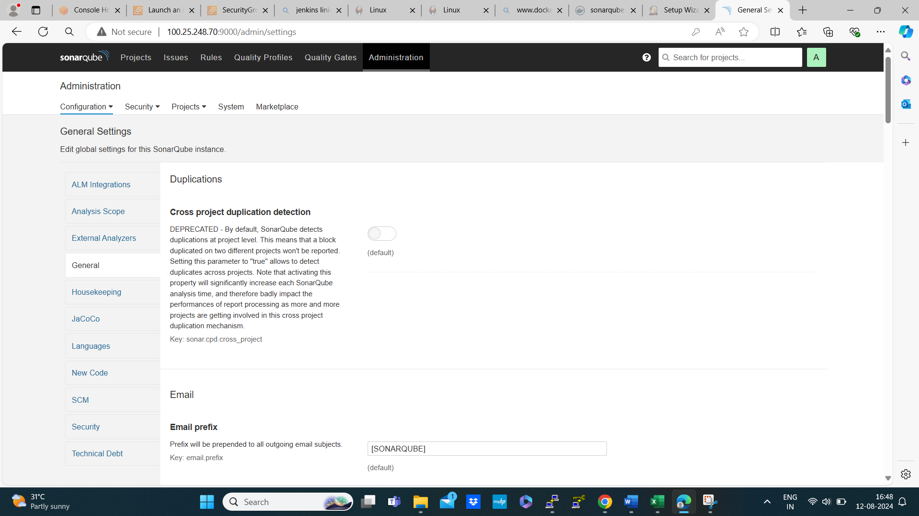

* Then go administration 🡪 security 🡪 users 🡪 generate the token

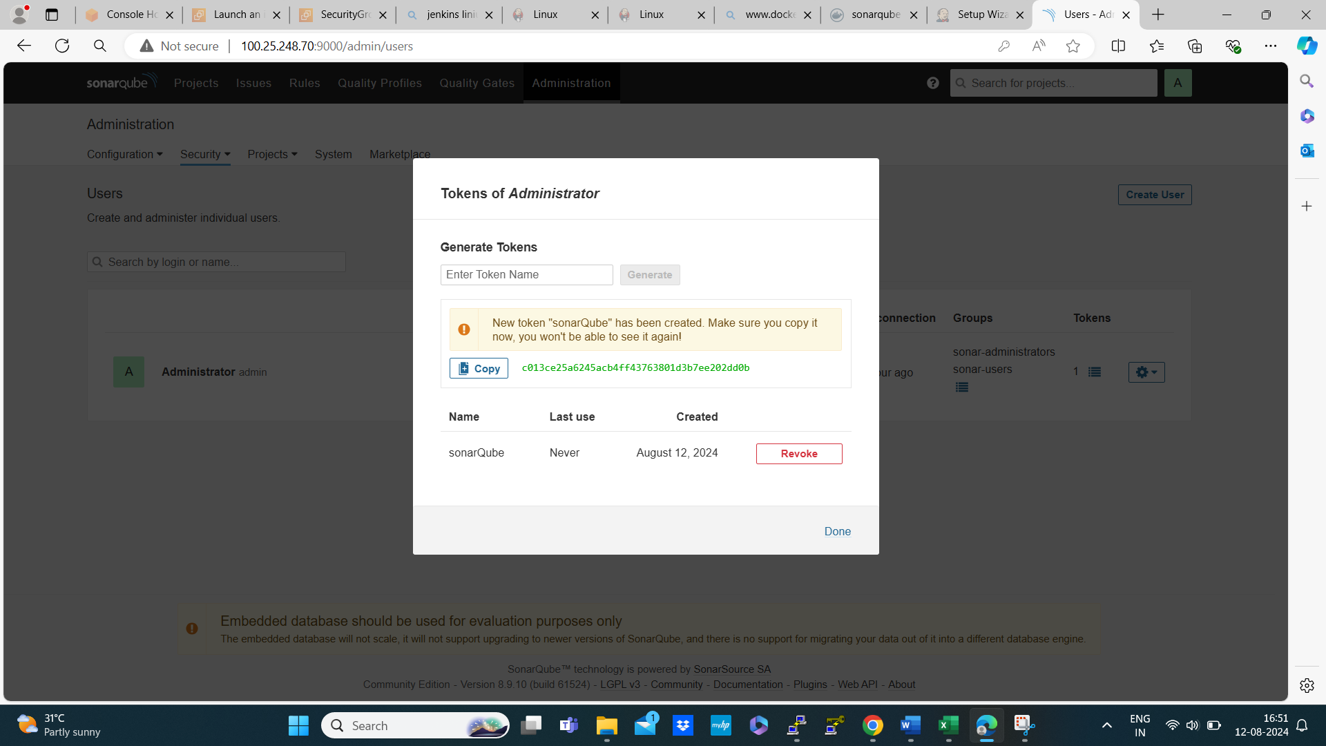

* We are generating a token with the name SonarQube
* And the generated token Is : c013ce25a6245acb4ff43763801d3b7ee202dd0b

**Launch another instance name it as Jenkins server**

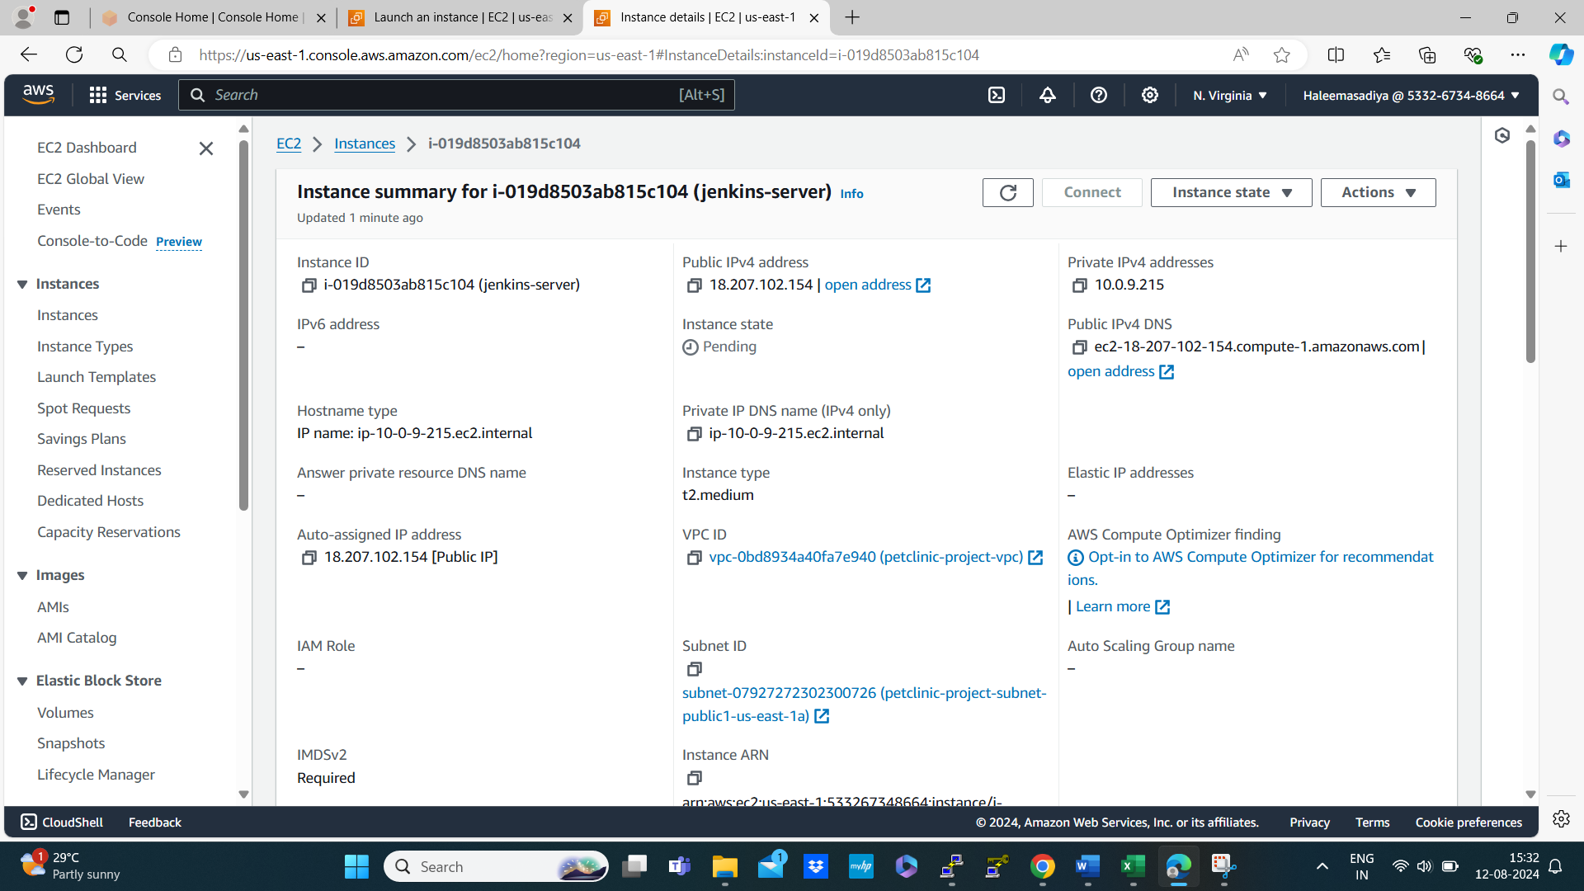

Allow ssh, https and sonarqube in the security groups

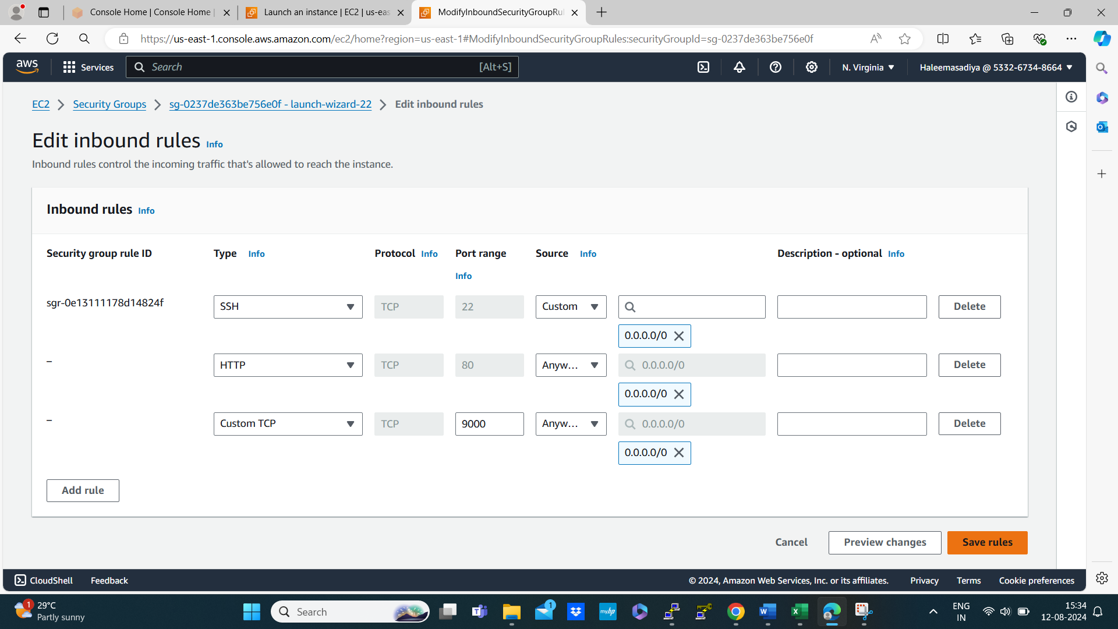

Then connect the instance through putty

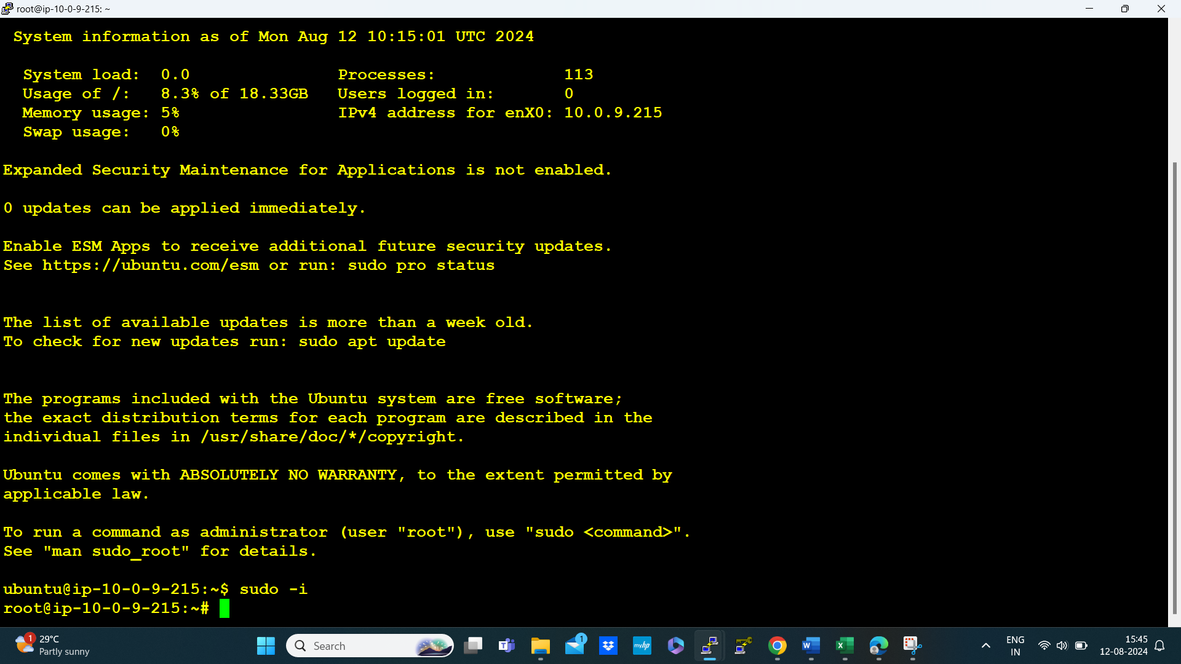

Then update the server using command # apt update

* Install jdk for Jenkins-server



* Install maven for Jenkins-server



* Then search for Jenkins installation steps in google

sudo wget -O /usr/share/keyrings/jenkins-keyring.asc \

https://pkg.jenkins.io/debian-stable/jenkins.io-2023.key

echo "deb [signed-by=/usr/share/keyrings/jenkins-keyring.asc]" \

https://pkg.jenkins.io/debian-stable binary/ | sudo tee \

/etc/apt/sources.list.d/jenkins.list > /dev/null

sudo apt-get update

sudo apt-get install Jenkins

* Copy the above commands past it on the Jenkins server

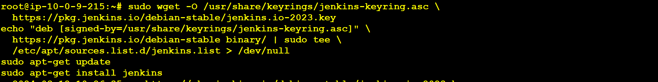

* Then check the status of the Jenkins if it is running or not if not start Jenkins server using the following command

# sudo systemctl enable Jenkins

# sudo systemctl start Jenkins

# sudo systemctl status Jenkins

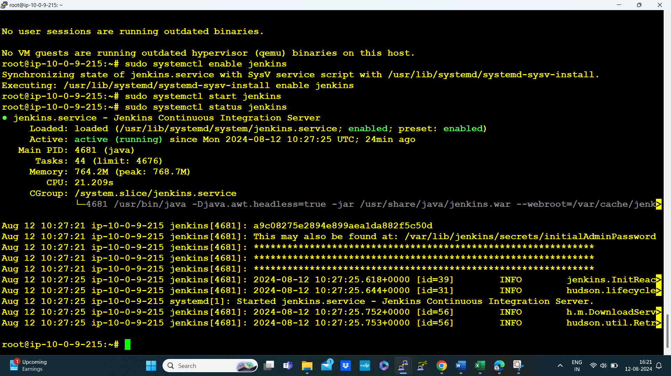

* Form here we need to identify public and the command for that is

# curl ipconfig.io



* Copy this public ip and past It in browser

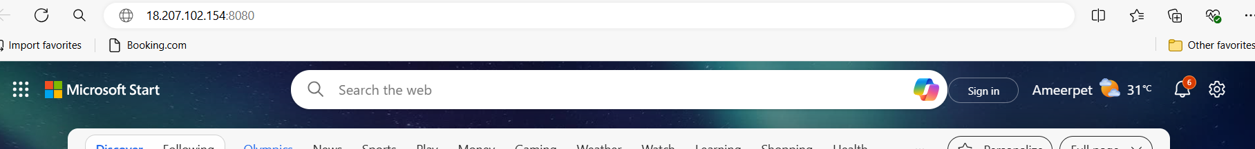

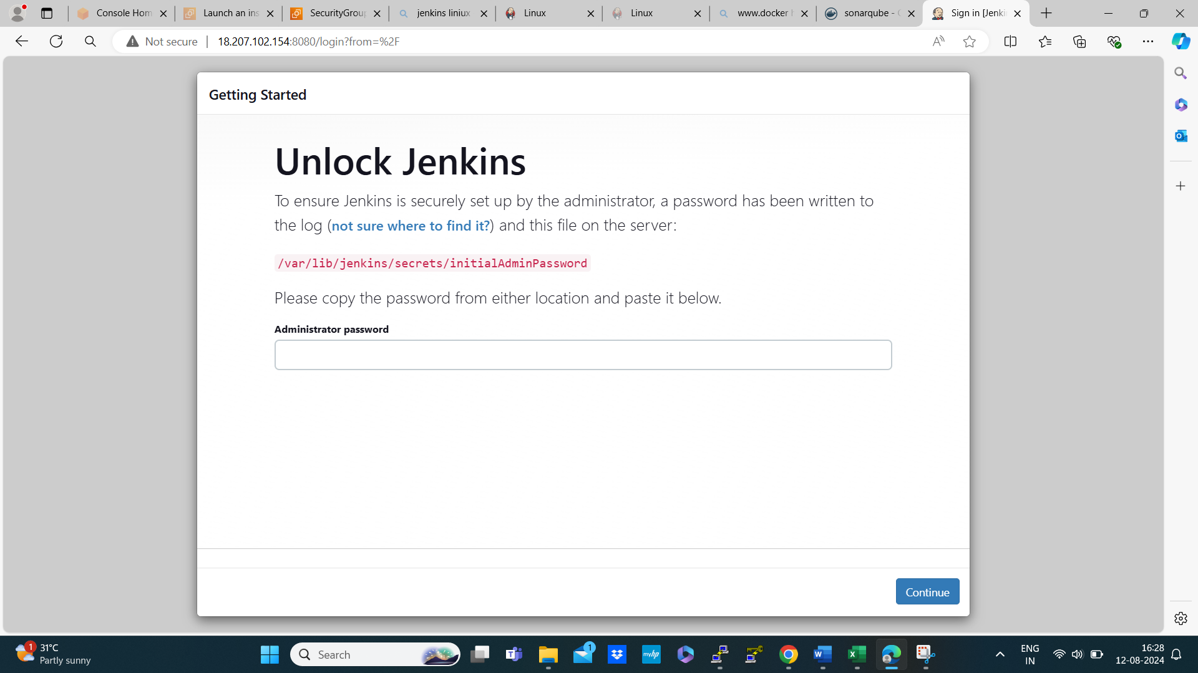

* Copy the path and past it in Jenkins server for the password



* Copy the above password and past it in the Jenkins page

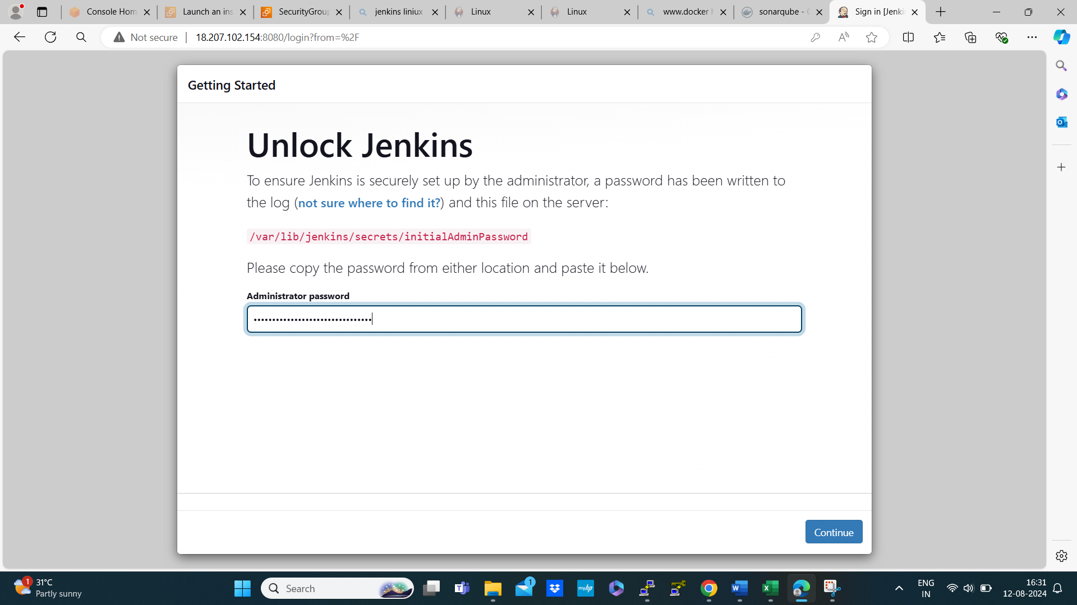

* Then click on continue

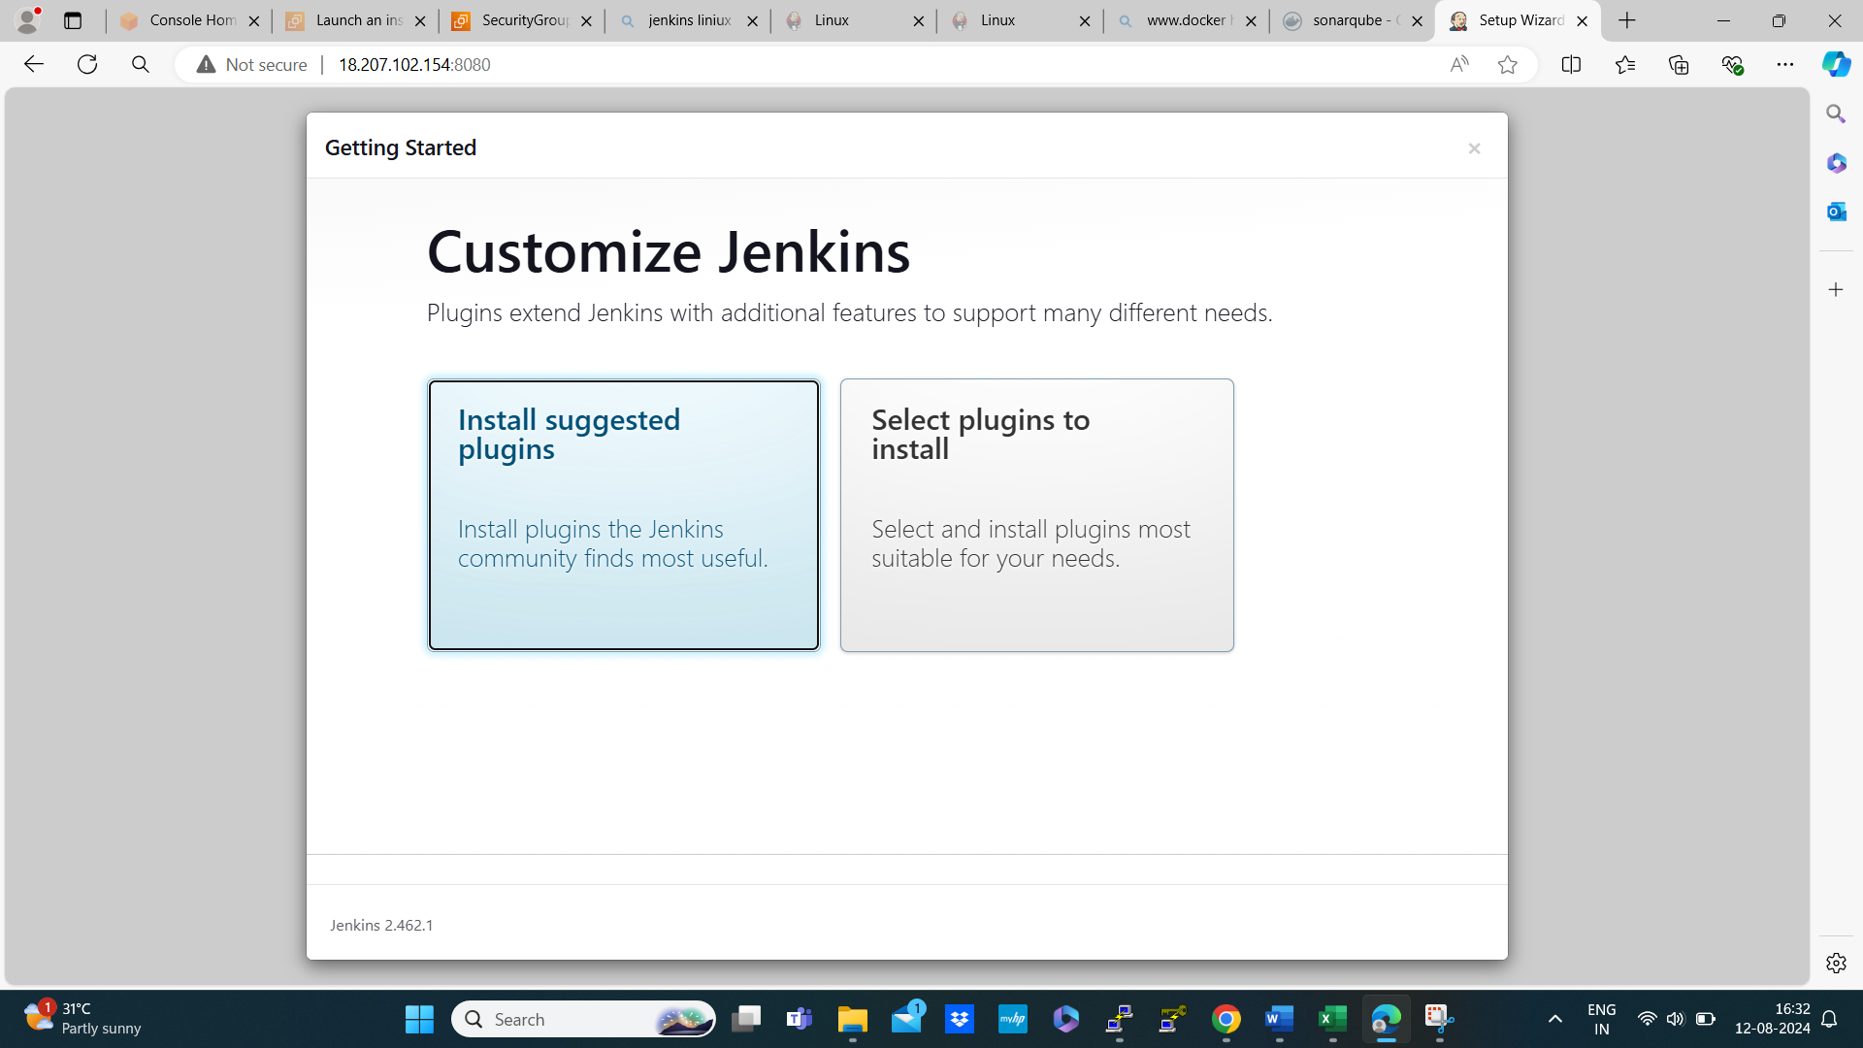

* Then click on install suggested plugins

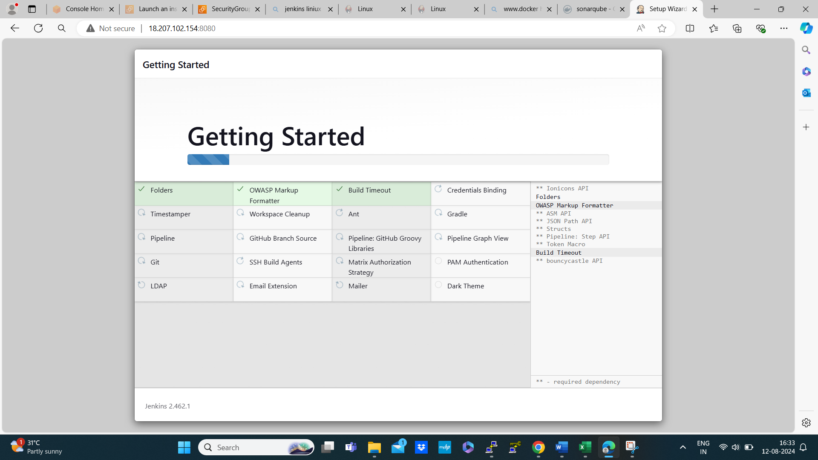

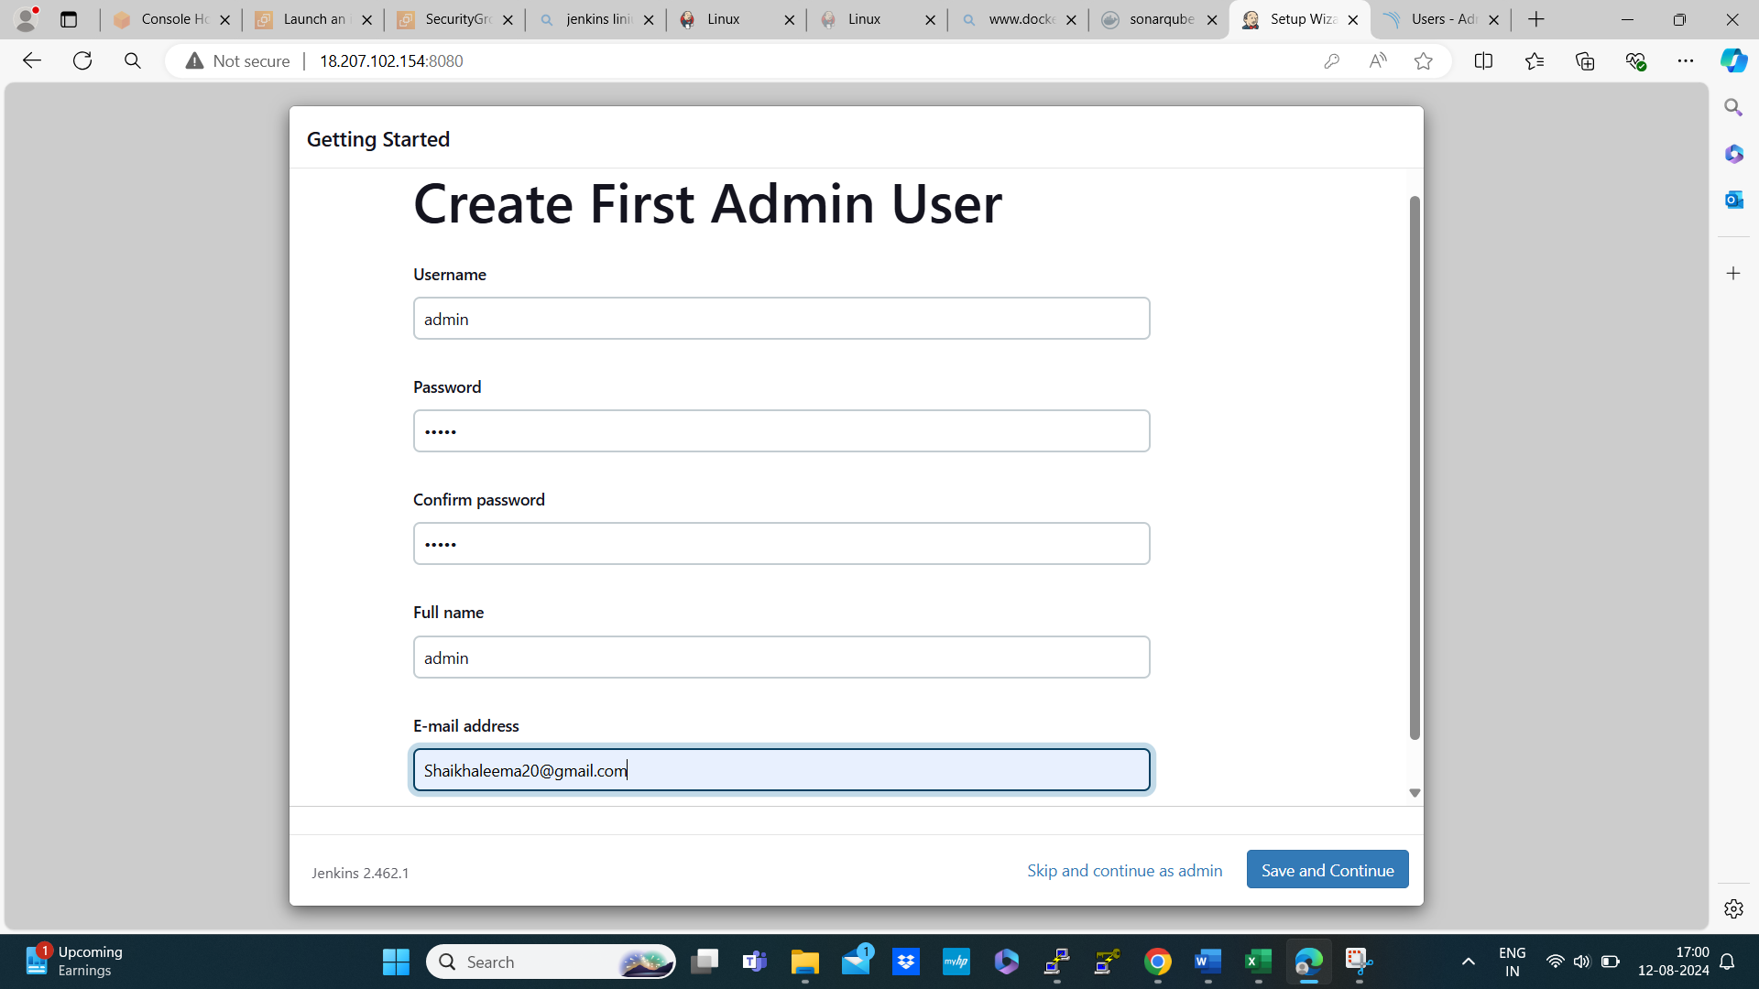

* Set username, password, and full name as admin and e-mail-id then save and continue

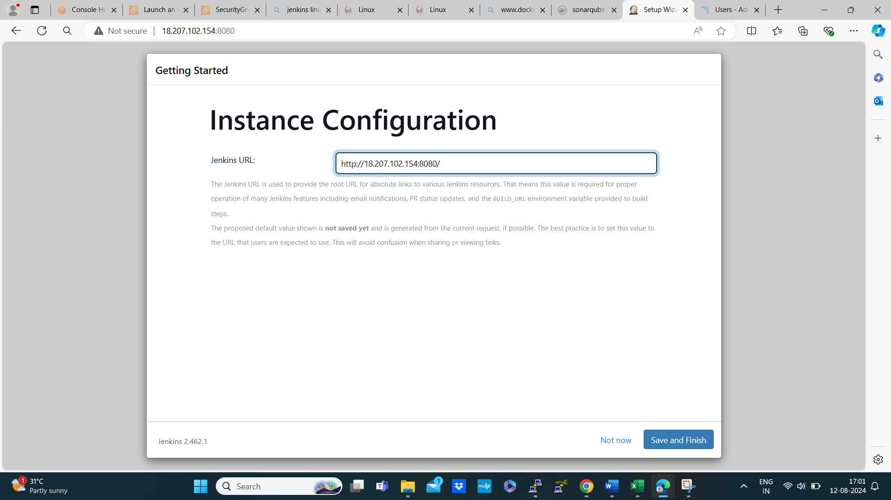

* Then save and finish

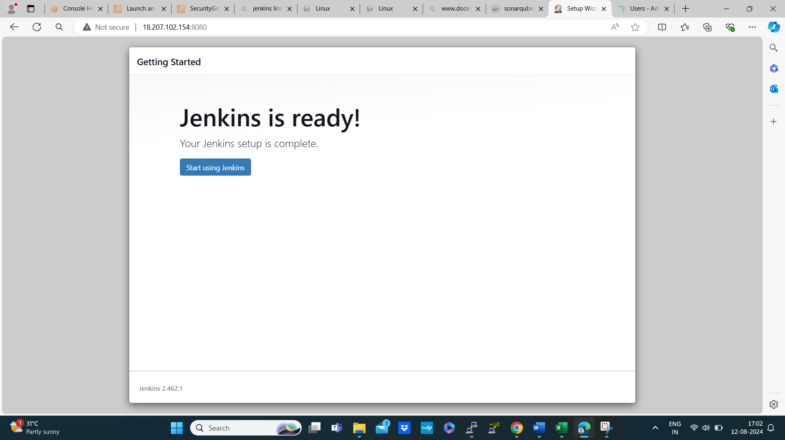

* Now Jenkins is ready to start

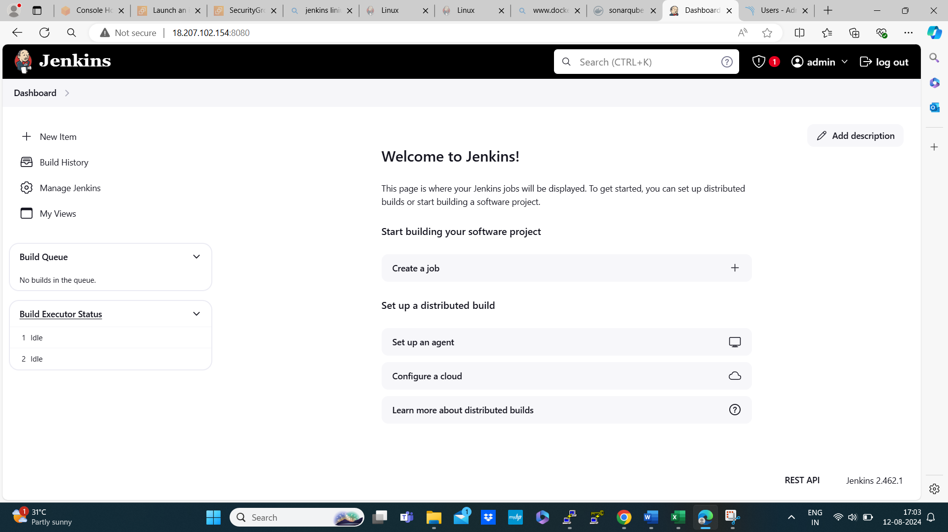

* We need to save the sonarqube token in Jenkins crediantials
* Manage Jenkins 🡪 credentials 🡪 system 🡪global credentials 🡪add credentials 🡪select secret text 🡪secret past id 🡪ID:sonar-token 🡪description:sonar-token🡪create

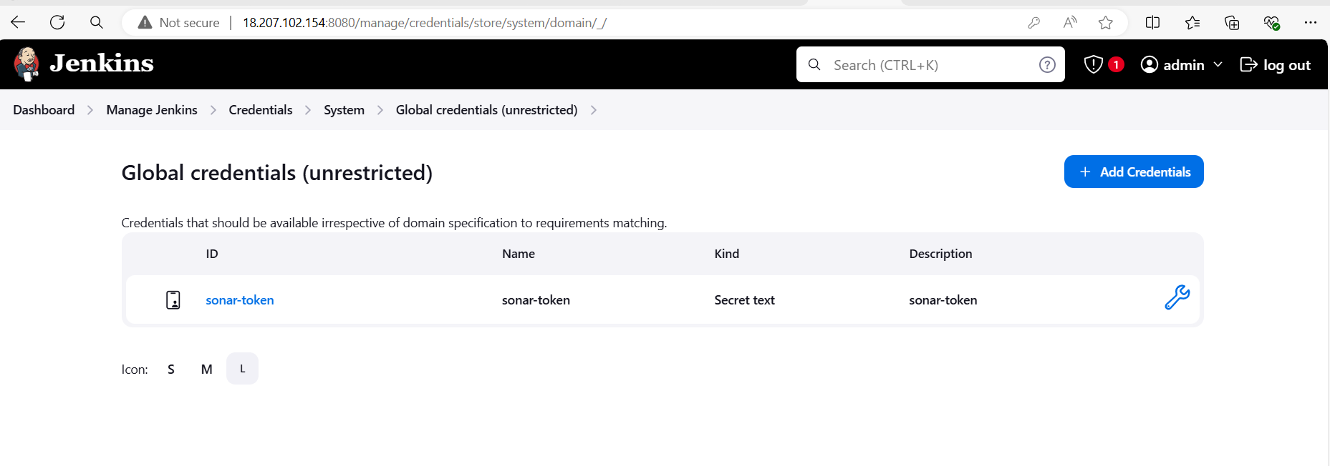

* Then add docker credential to Jenkins

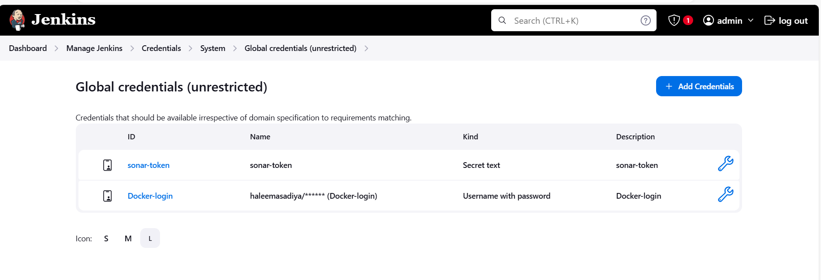

* We need to install the plugins first
* Go to plugins 🡪 available plugins 🡪install maven integration 🡪 config File provider 🡪 jira 🡪 Pipeline Maven Integration 🡪 sonar scanner 🡪OWASP dependency-check 🡪 eclips temurin installer 🡪 docker 🡪 docker pipeline 🡪 docker commons then install 🡪 restart Jenkins safe restart 🡪 then login

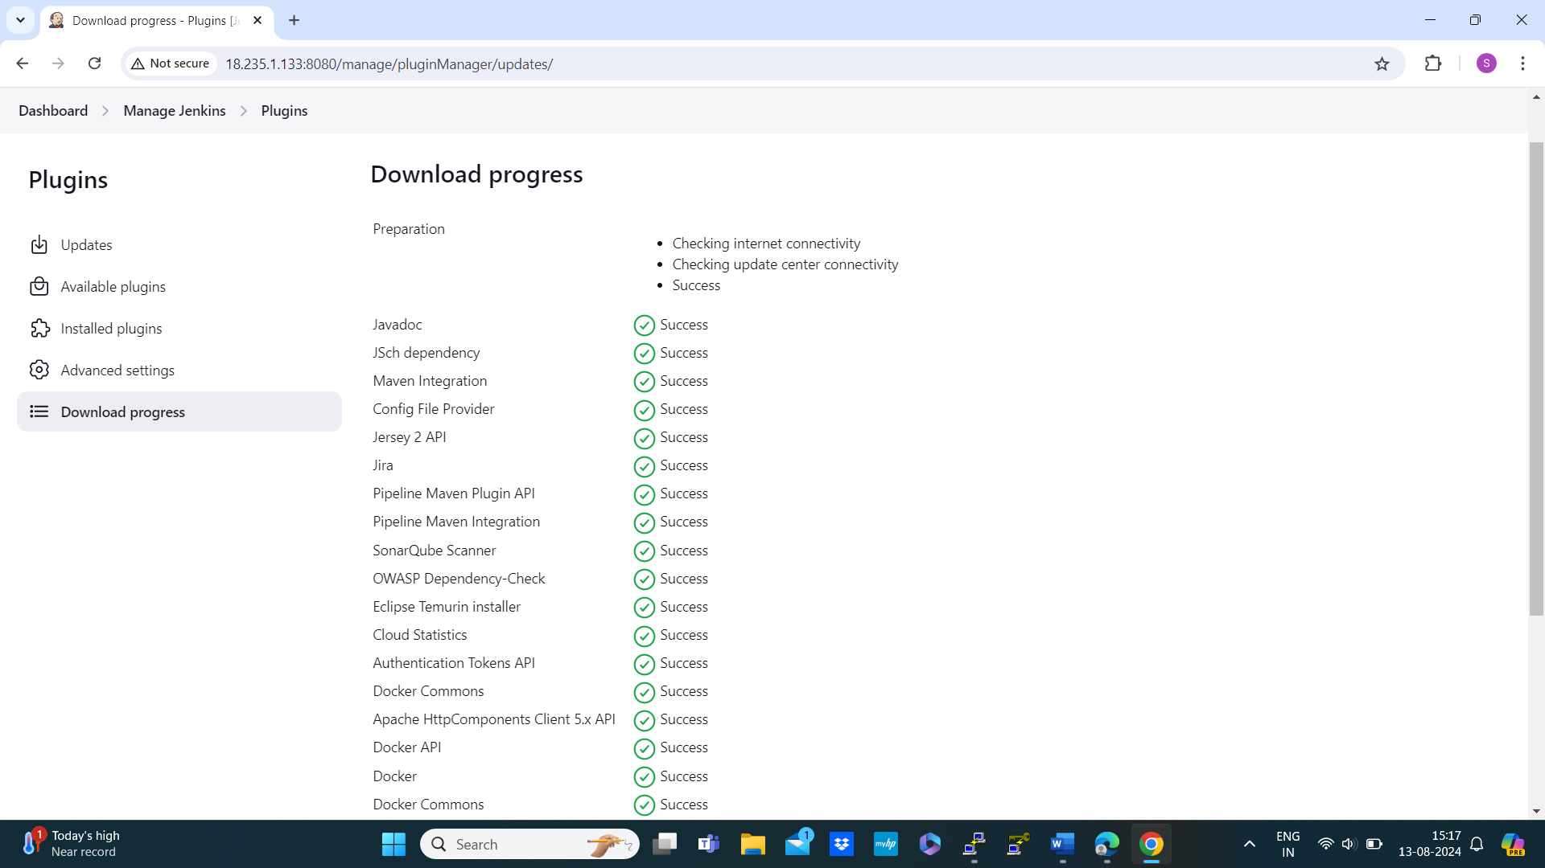

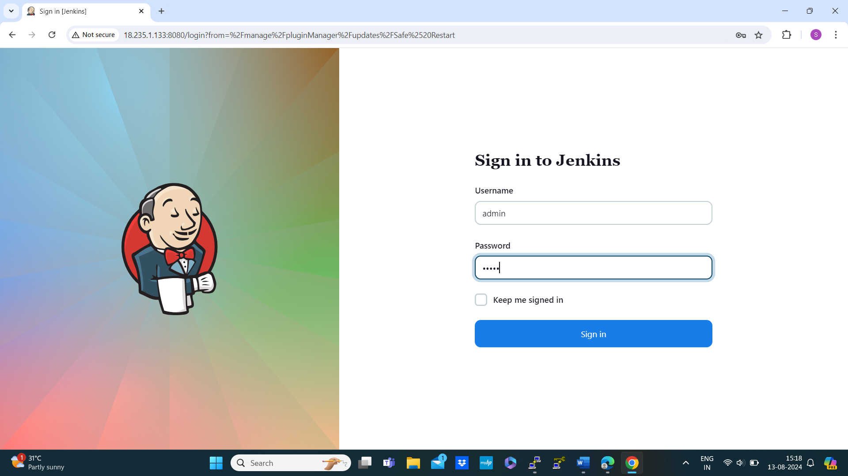

* Then we need to configure our systems
* Manage Jenkins 🡪 system configuration 🡪 system 🡪sonar 🡪 add SonarQube 🡪name: sonar-server 🡪 server URL: server url past 🡪 sonar token 🡪apply & save

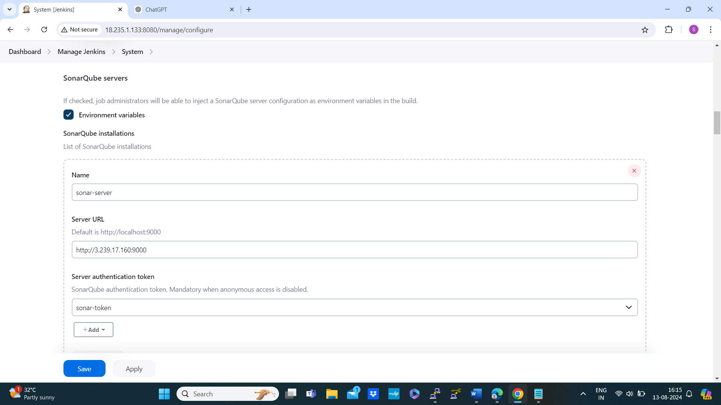

* Manage Jenkins 🡪 tools 🡪 jdk installations 🡪 name:jdk17 🡪 check install automaticall 🡪 install from adoptium.net 🡪version:jdk-17.0.24+7

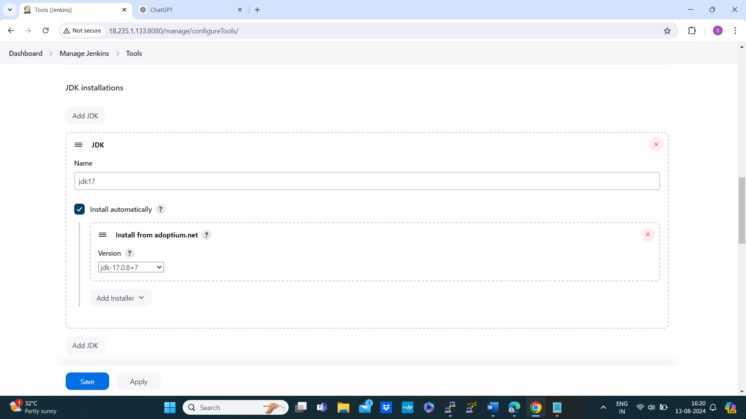

* Sonarqube scanner installations 🡪 name: sonar-scanner 🡪 version: SonarQube scanner 6.1.0.4477

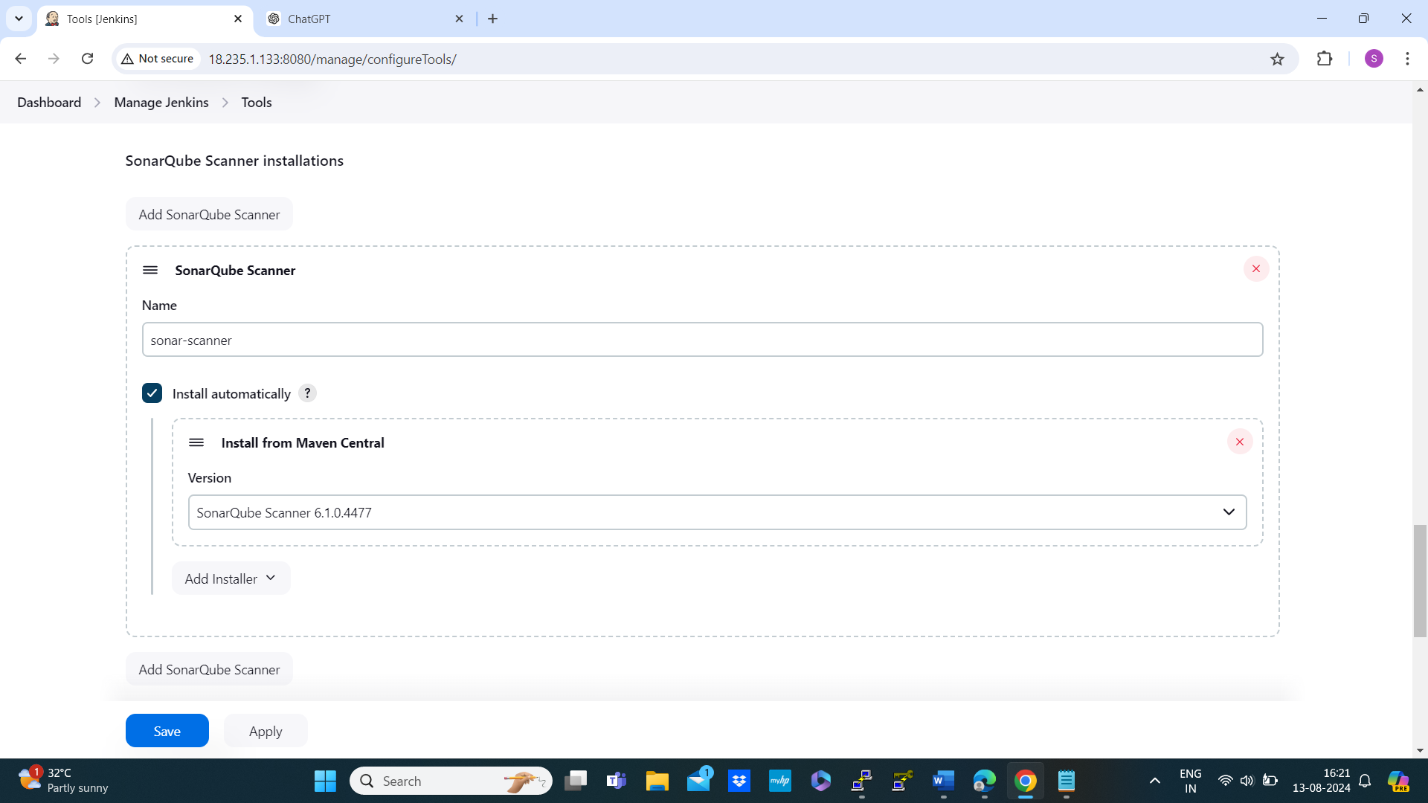

* Maven 🡪 name: maven3 🡪 version: 3.6.2 🡪 dependency check 🡪install automatically 🡪 install from github.com 🡪dependency -check 8.4.2

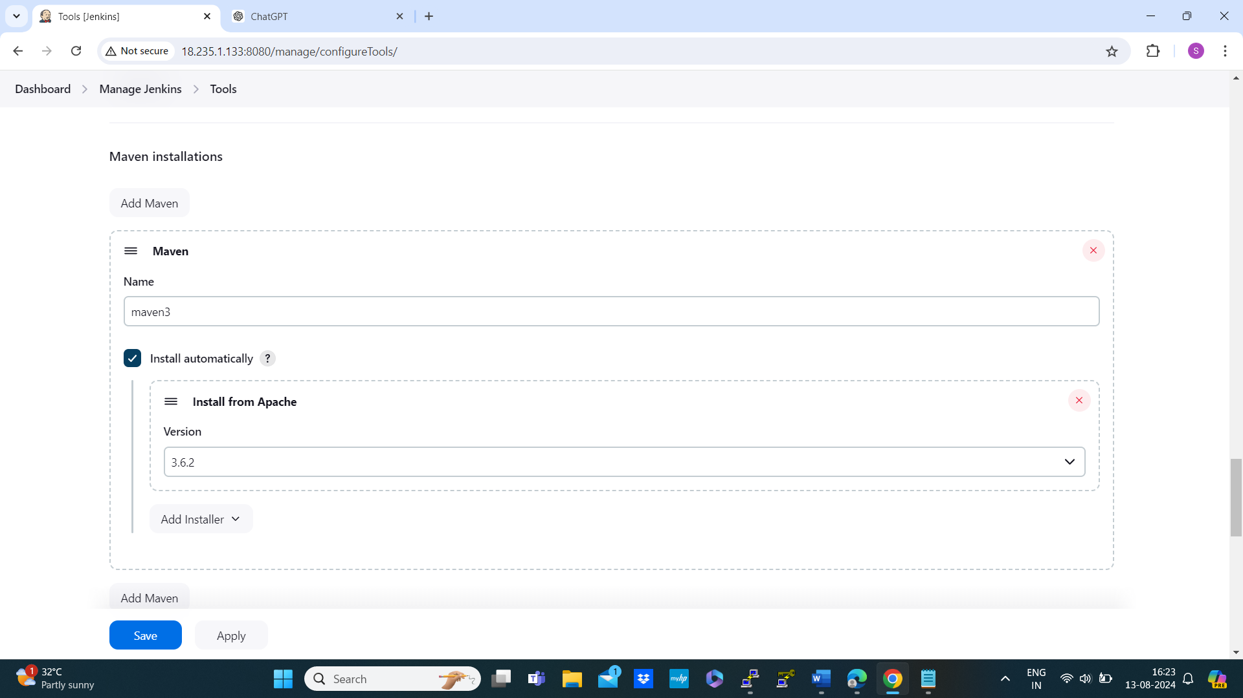

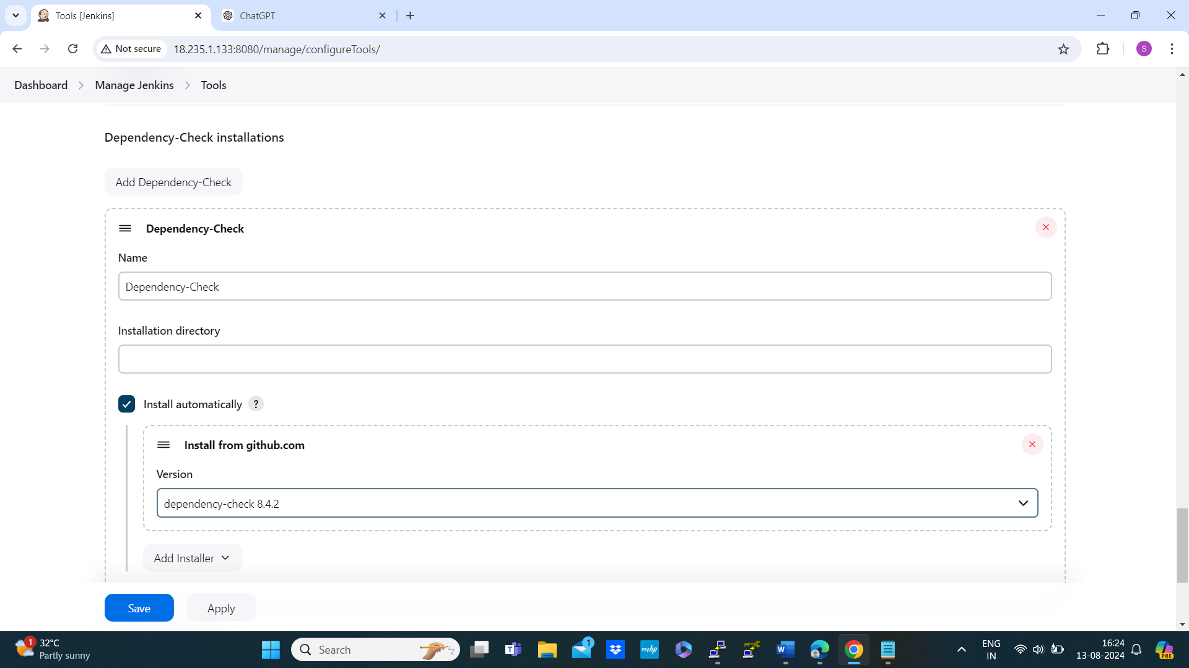

* Docker installations 🡪name:Docker 🡪 install automatically: download from docker.com -version: latest apply and save

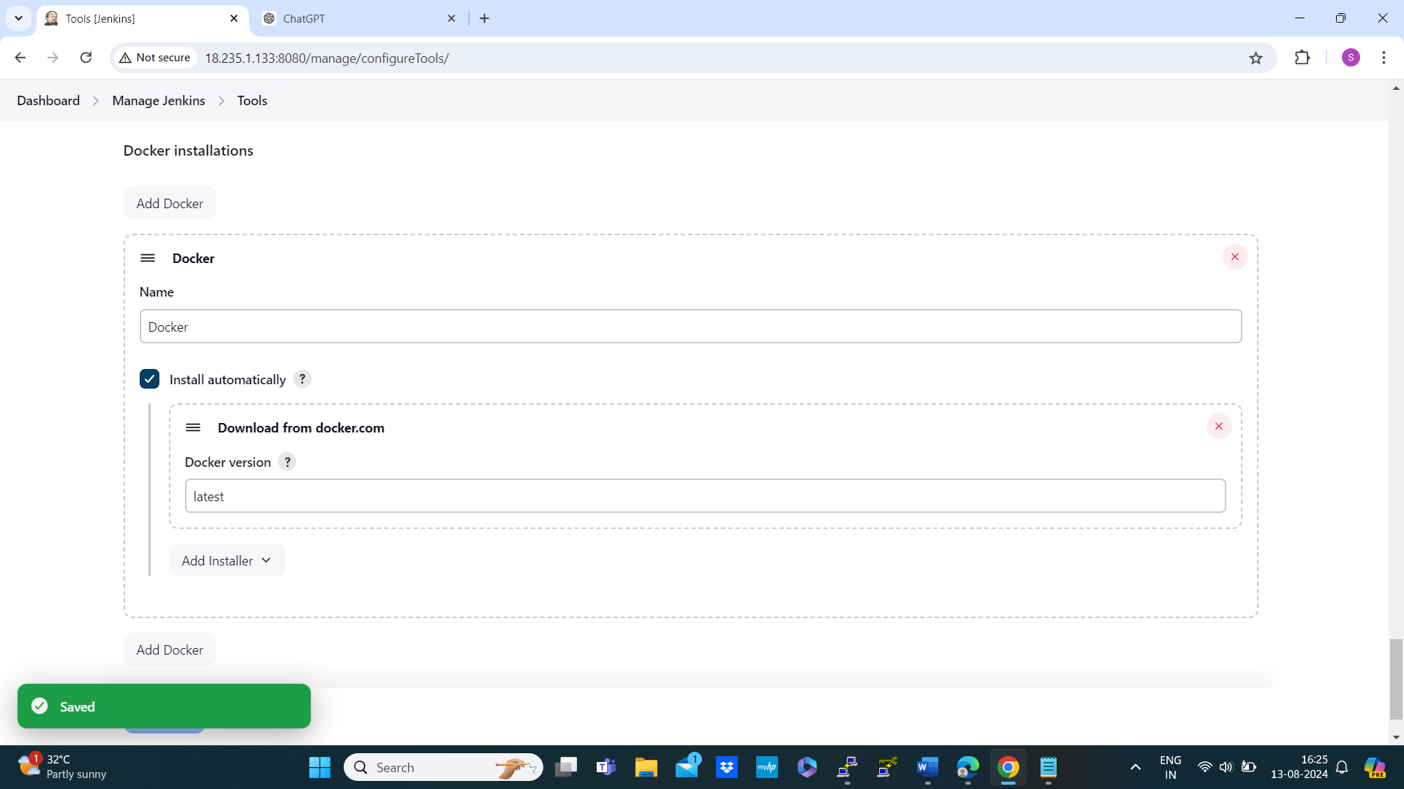

Then install trivy in Jenkins-server

* Installation steps

sudo apt-get install wget apt-transport-https gnupg lsb-release

wget -qO - https://aquasecurity.github.io/trivy-repo/deb/public.key | sudo apt-key add -

echo deb https://aquasecurity.github.io/trivy-repo/deb $(lsb_release -sc) main | sudo tee -a /etc/apt/sources.list.d/trivy.list

sudo apt-get update

sudo apt-get install trivy

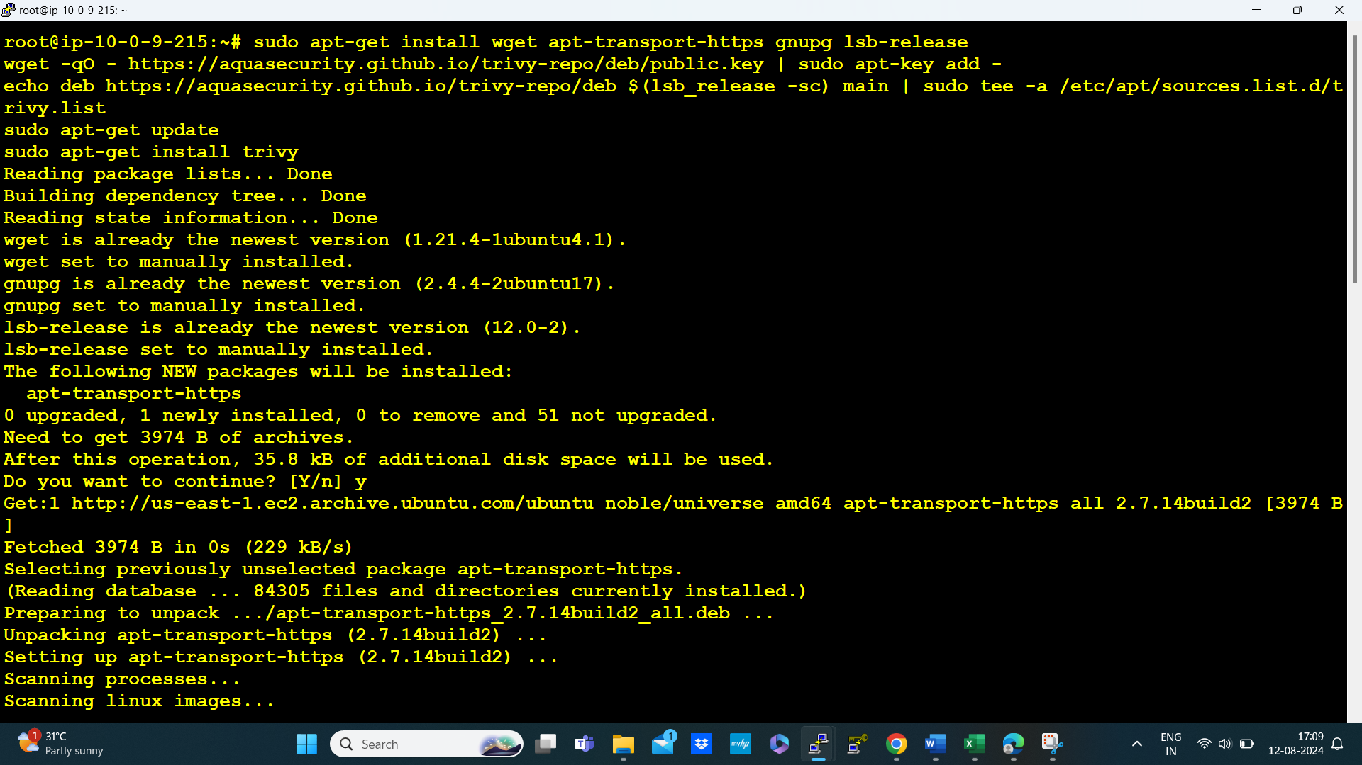

* Check the version of the trivy



* Then install docker in the Jenkins sever



* In the Jenkins server check for the user here by default user was created
* Command to check the uses is # cat /etc/passwd
* Set password for Jenkins the command

# passwd Jenkins

# new password: 123

# re-enter new password:123

**Then launch a slave-server then connect to slave server using putty**

* Then run the following commands

# sudo -i

# apt update

# in Jenkins server login docker first using the following command # docker login

Then enter username and password of docker

. in the slave server create a user named Jenkins for that the command is

# adduser Jenkins 🡪 then create password:123

. for giving root permission to the user

# visudo

Jenkins ALL=(ALL) NOPASSWD :ALL

# cd .ssh/ 🡪 authorized_keys 🡪 cat authorized_keys

. come back to Jenkins server generate key, the command is

Ssh – keygen

Ls -a

.ssh

Cd .ssh/ - two keys appear copy public key in slave node ssh-copy-id jenkins@<pvtip>

# ssh-keygen -t rsa

# cd .ssh/

# cat id_rsa.pub 🡪copy the key

.back to slave-server

~/ .ssh # cat > authorized_keys

Past the key here then ctl+d for exit

. lets check that can we able to connect slave-server from Jenkins server

.in the slave server perform the command to get publicip and the command is

# curl ipconfig.io 🡪 we will get public ip here copy the public ip

.back to Jenkins server

# ssh -I ubuntu@<past the public ip here> 🡪unable to eatablish password less connection

**Creating a job using Jenkins dashboard**

* Dashboard 🡪 new item 🡪name: App-PetClinic 🡪 pipeline 🡪ok now add description of the project

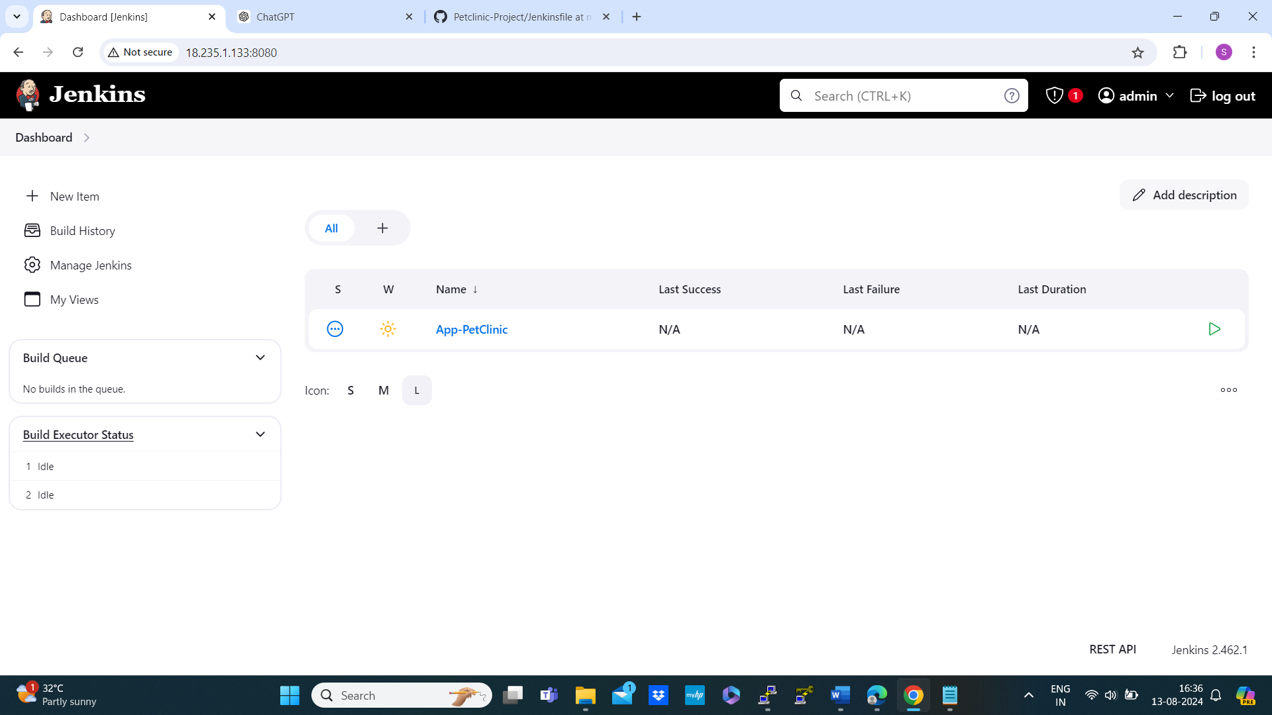

* Go to github account then fork the repository copy the url and past it to stage(‘checkout’) 🡪 stage(‘build’) uncomment # sh ‘mvn clean package -Dmaven.test.skip=true’ 🡪 then copy the code and past it into pipeline(Jenkins 🡪configure) 🡪discard old builts:7 🡪 select githook trigger then apply and save

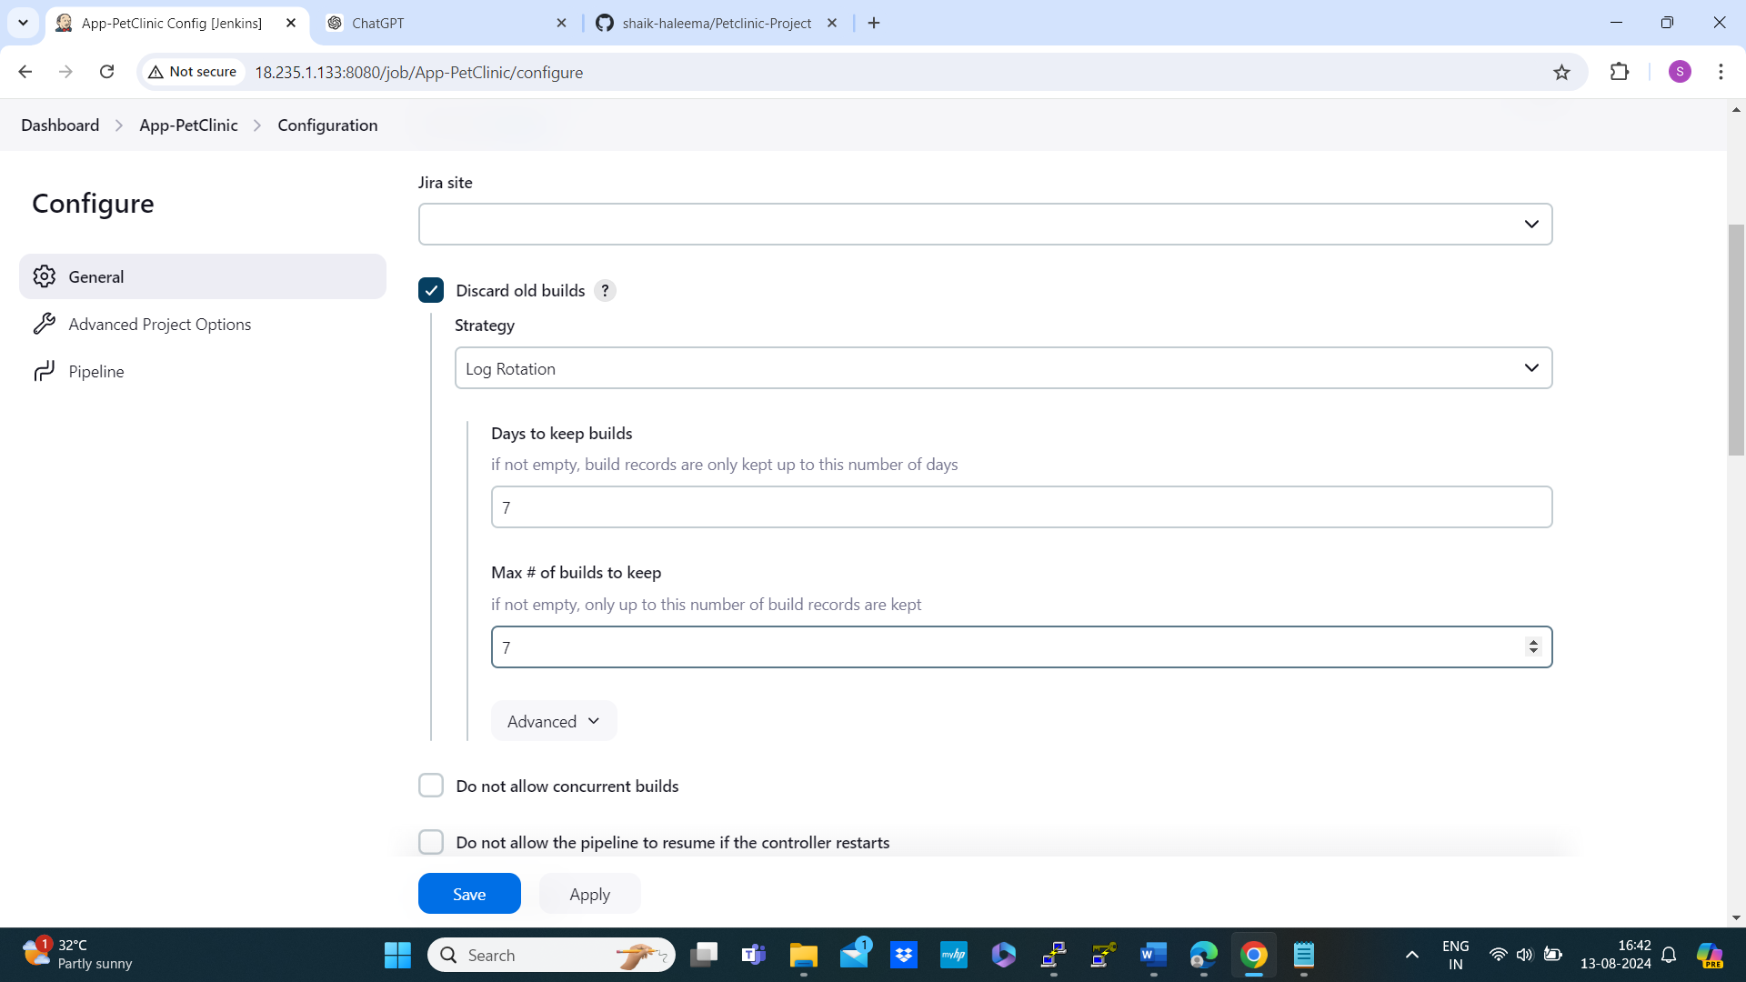

* It time to setting up webhooks for that go to github account

Navigate to 🡪settings 🡪left side notice that webhooks 🡪 add webhook 🡪use passkey 🡪 at the place of payload URL: past Jenkins url 8000/github-webhook/ 🡪connection type: application JSON 🡪event trigger: send me everything(based on your requirement) 🡪active 🡪 Add webhook, if it is done green tick will appear

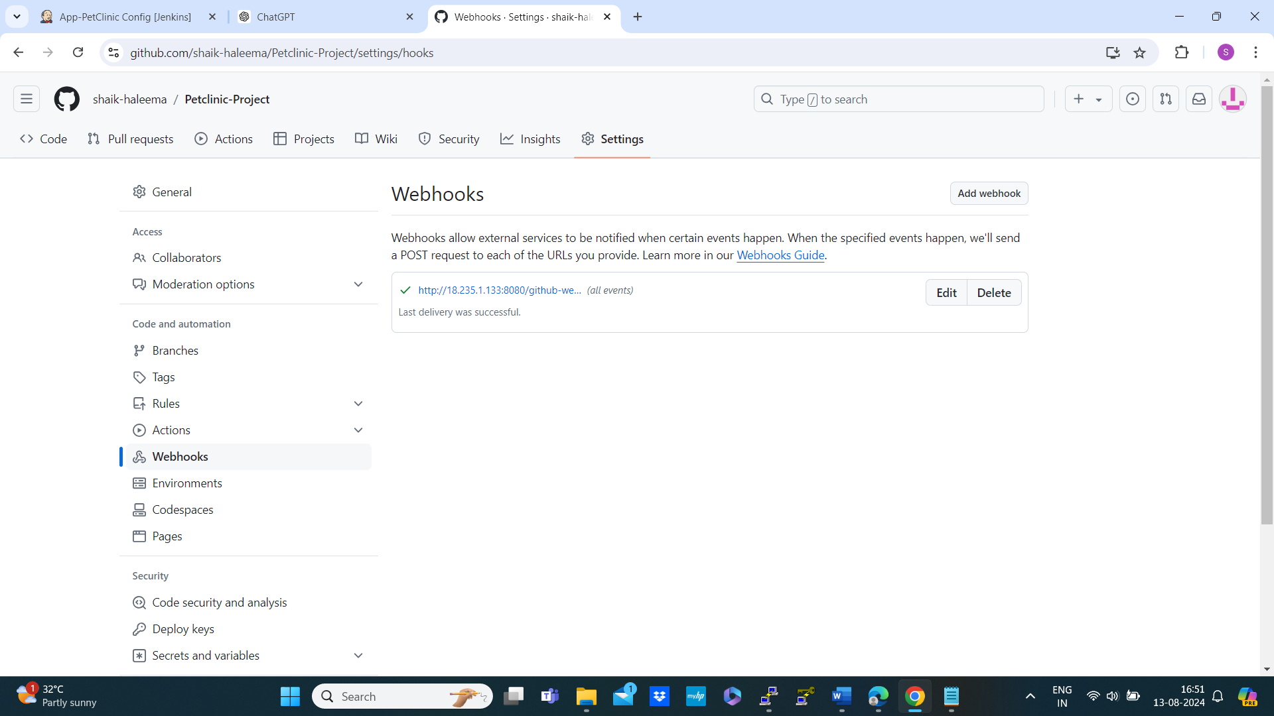

* Then back to configure

Made changes in the code according to your credentials

DOCKER_REPO = ‘docker.io/<docker username>’ apply save

* Back to manage Jenkins 🡪 credentials 🡪 store scope to Jenkins 🡪 system 🡪global credentials 🡪 add credentials 🡪 secret text 🡪secret: p/w of docker 🡪ID:Docker-Passwd same copy in the description

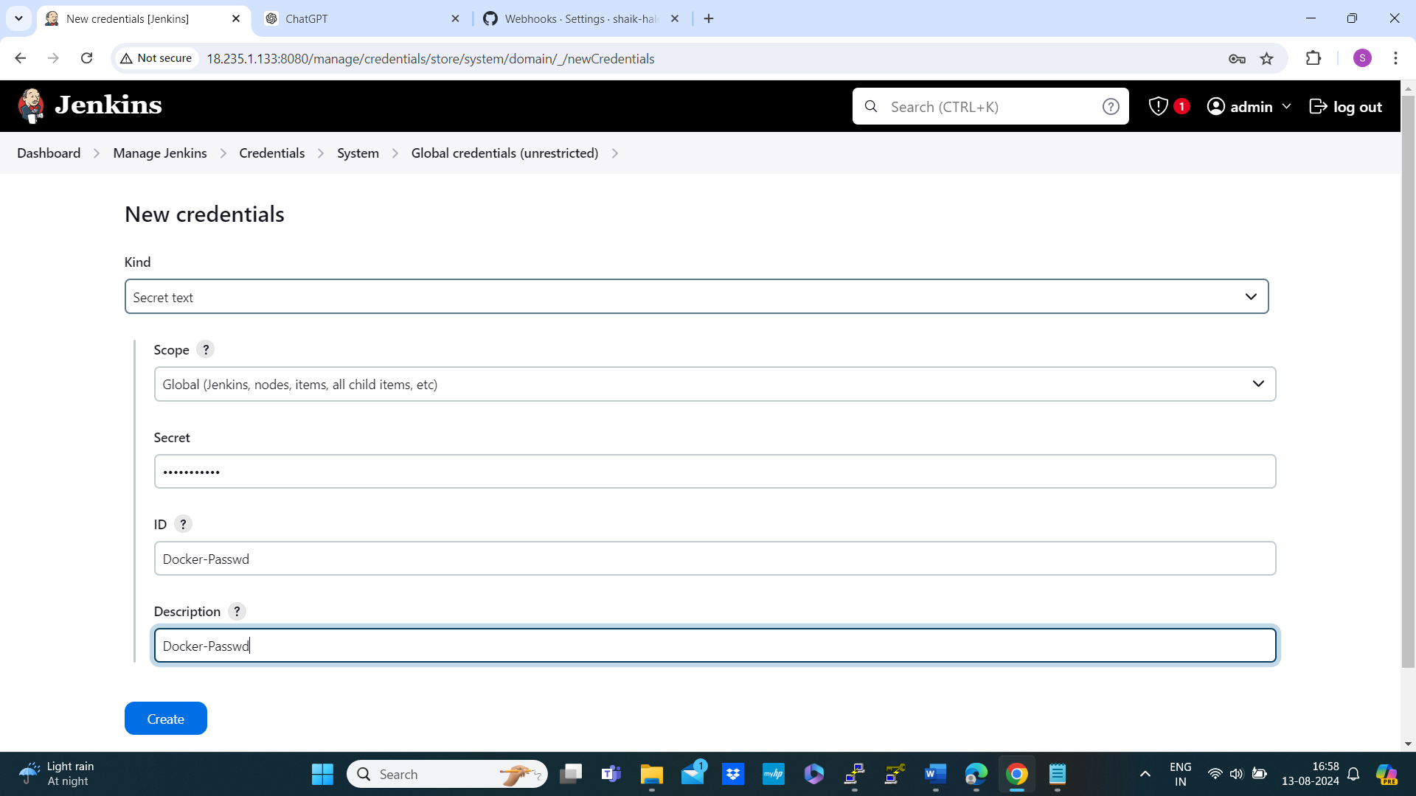

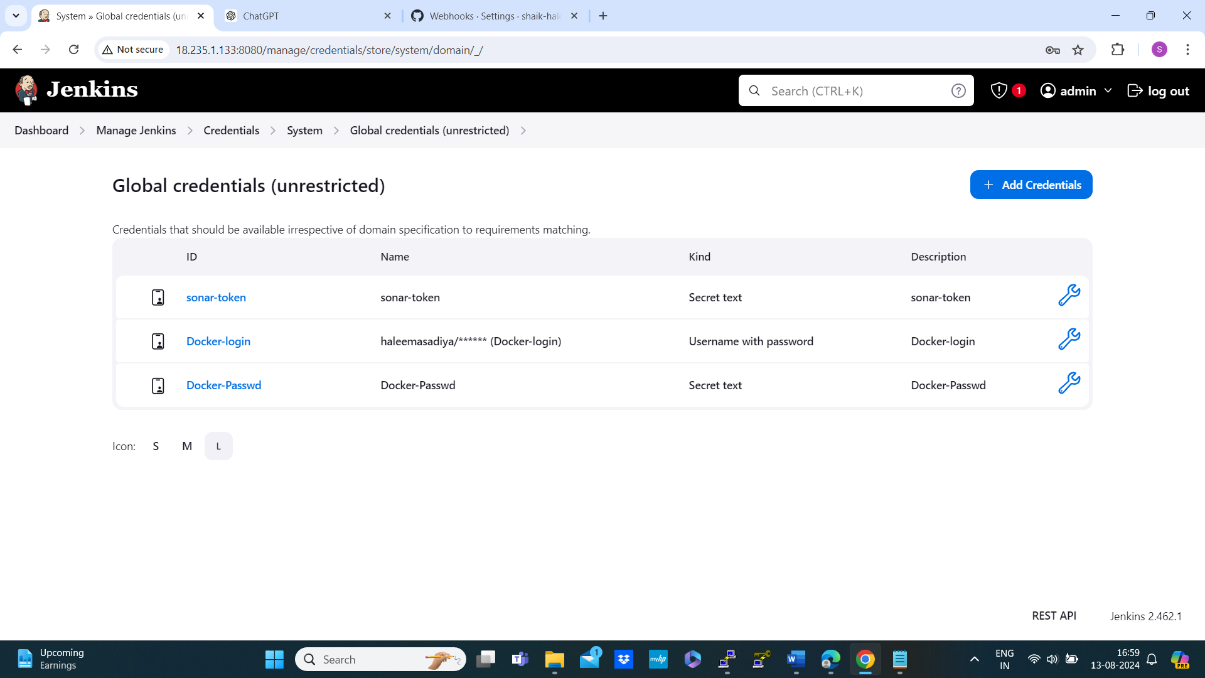

* Back to dashboard 🡪 configure 🡪DOCKER_PASS = credentials(‘Docker-Passwd’)
* Go to pipeline syntax 🡪sneppet generator: git Git 🡪copy repo url 🡪branch: master 🡪generate pipeline script 🡪copy from here and past it to pipeline script: stage(‘checkout’) urls place
* Check docker compose is installed or not in Jenkins server

# docker-compose –version

Docker compose digital ocean copy the commands in the documentation and past it in the Jenkins server

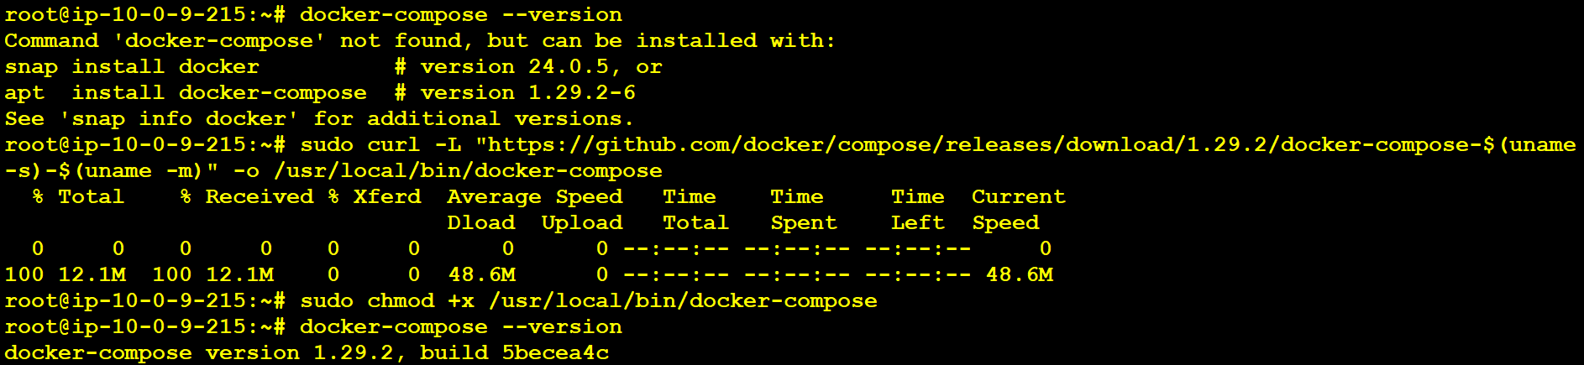

* After configuring all the steps apply and save then build

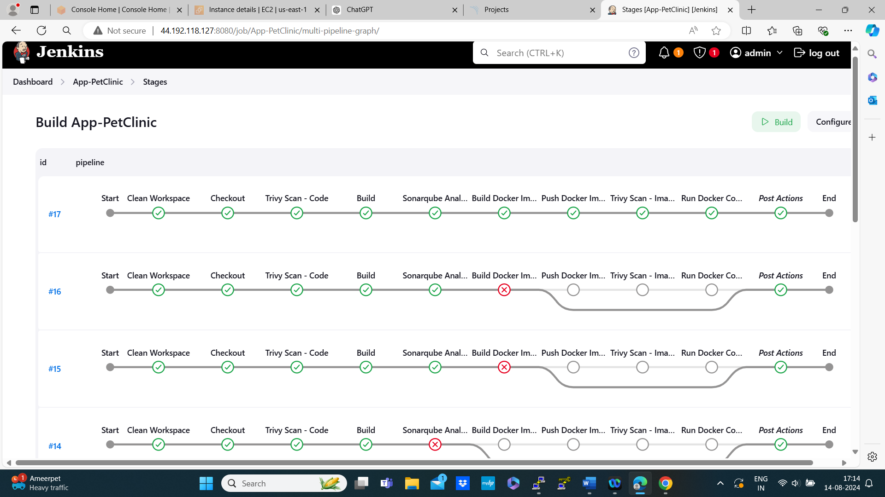

**Finally succeed**

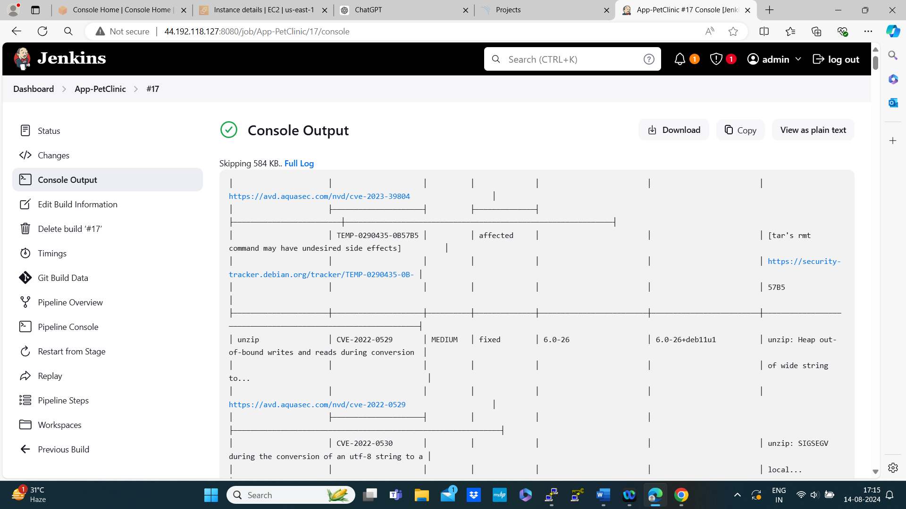



**Container also created**

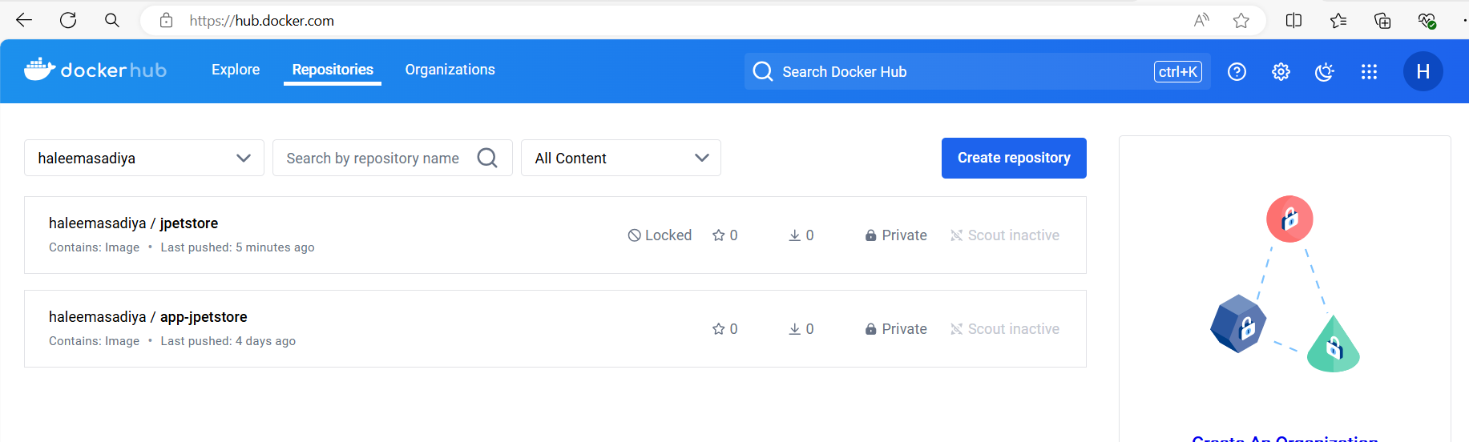

**Install pipeline view plugin to get the output like this**

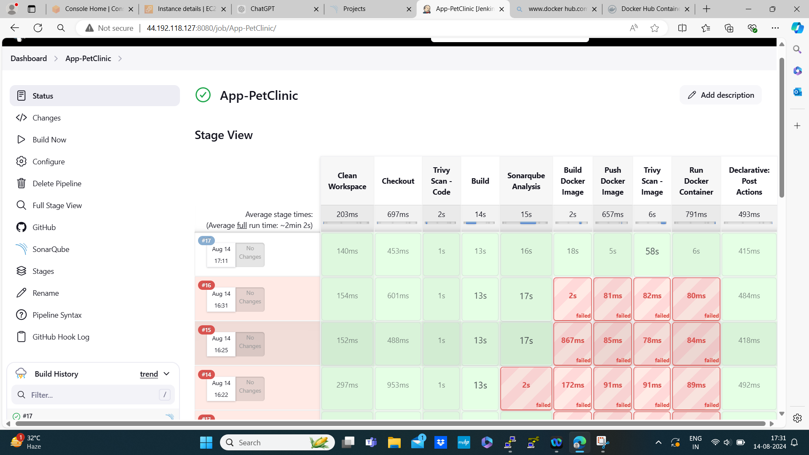

**Sonar view**

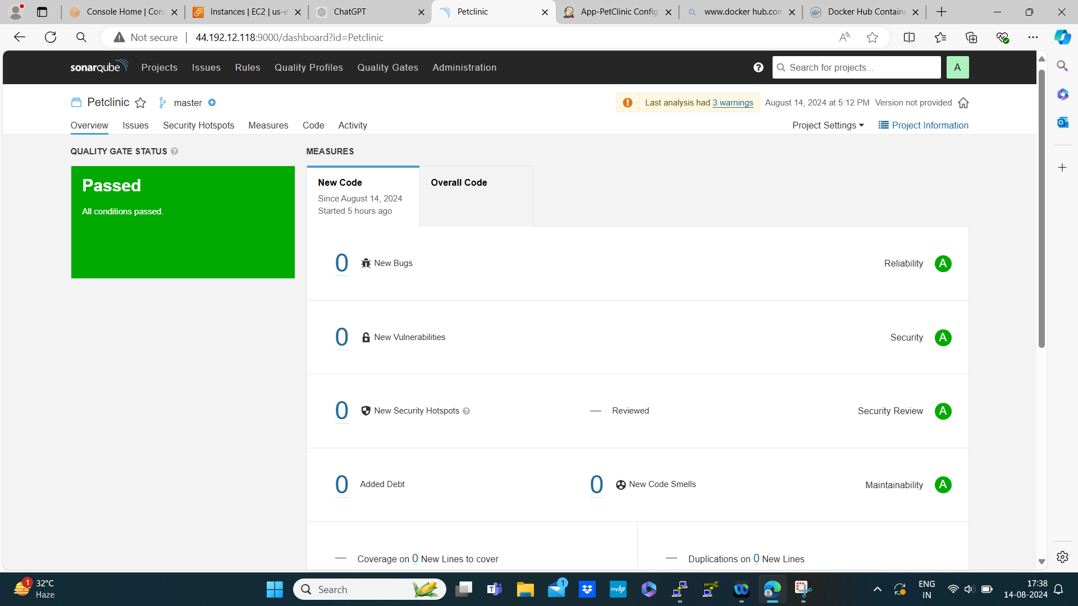

Pipeline syntax

pipeline {

agent any

environment {

SCANNER_HOME = tool 'sonar-scanner'

DOCKER_REPO = 'docker.io/haleemasadiya'

APP_NAME = 'jpetstore'

}

stages {

stage('Clean Workspace') {

steps {

cleanWs()

}

}

stage('Checkout') {

steps {

git branch: 'main', url: 'https://github.com/shaik-haleema/Petclinic-Project.git'

}

}

stage('Trivy Scan - Code') {

steps {

script {

sh "trivy fs --exit-code 0 --severity HIGH,CRITICAL ."

}

}

}

stage('Build') {

steps {

sh 'mvn clean package -Dmaven.test.skip=true'

}

}

stage('Sonarqube Analysis') {

steps {

withSonarQubeEnv('sonar-server') {

sh '''$SCANNER_HOME/bin/sonar-scanner -Dsonar.projectName=Petclinic \

-Dsonar.java.binaries=. \

-Dsonar.projectKey=Petclinic'''

}

}

}

stage('Build Docker Image') {

steps {

script {

def dockerImage = "${env.DOCKER_REPO}/${env.APP_NAME}"

def dockerTag = "${dockerImage}:${env.BUILD_NUMBER}"

withCredentials([string(credentialsId: 'Docker-Passwd', variable: 'DOCKER_PASSWD')]) {

sh "echo ${DOCKER_PASSWD} | docker login -u haleemasadiya --password-stdin"

sh "docker build -t ${dockerTag} ."

}

}

}

}

stage('Push Docker Image') {

steps {

script {

def dockerImage = "${env.DOCKER_REPO}/${env.APP_NAME}"

def dockerTag = "${dockerImage}:${env.BUILD_NUMBER}"

withCredentials([string(credentialsId: 'Docker-Passwd', variable: 'DOCKER_PASSWD')]) {

sh "echo ${DOCKER_PASSWD} | docker login -u haleemasadiya --password-stdin"

sh "docker push ${dockerTag}"

}

}

}

}

stage('Trivy Scan - Image') {

steps {

script {

def dockerImage = "${env.DOCKER_REPO}/${env.APP_NAME}"

def dockerTag = "${dockerImage}:${env.BUILD_NUMBER}"

sh "trivy image ${dockerTag}"

}

}

}

stage('Run Docker Container') {

steps {

script {

def dockerImage = "${env.DOCKER_REPO}/${env.APP_NAME}"

def dockerTag = "${dockerImage}:${env.BUILD_NUMBER}"

withCredentials([string(credentialsId: 'Docker-Passwd', variable: 'DOCKER_PASSWD')]) {

sh "echo ${DOCKER_PASSWD} | docker login -u haleemasadiya --password-stdin"

sh "docker-compose -f docker-compose.yaml up -d"

}

}

}

}

}

post {

always {

script {

// Ensure variables are available in this block

def dockerImage = "${env.DOCKER_REPO}/${env.APP_NAME}"

def dockerTag = "${dockerImage}:${env.BUILD_NUMBER}"

// Clean up by removing the local Docker image

sh "docker rmi -f ${dockerTag}"

}

}

}

}

**Conclusion**

Following this guide, you can successfully set up a CI/CD pipeline using Jenkins, SonarQube, Docker, and AWS. This pipeline automates the build, test, and deployment processes, making your development workflow more efficient and reliable.